Question 1
public class Car {
String brand;
int year;
int mileage;
void display() {
System.out.println(brand + " - " + year + " - " + mileage + "km");
}
public static void main(String[] args) {
Car c1 = new Car();
c1.brand = "Toyota";
c1.year = 1999;
c1.mileage = 7697000;
Car c2 = new Car();
c2.brand = "BMW";
c2.year = 2020;
c2.mileage = 30000;
Car c3 = new Car();
c3.brand = "Honda";
c3.year = 2008;
c3.mileage = 150000;
c1.display();
c2.display();
c3.display();
}
}
Output
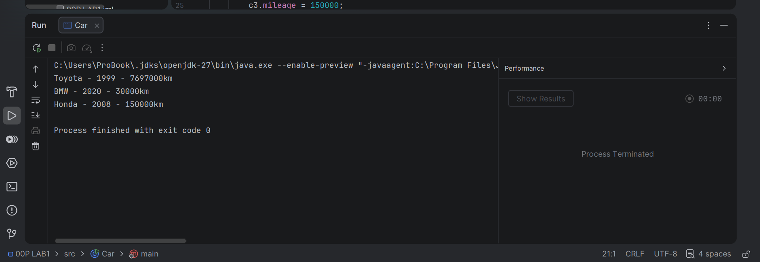

QUESTION 2 CODE

public class Car {
String brand;
int year;
int mileage;
void display() {
System.out.println(brand + " - " + year + " - " + mileage + "km" + " Antique: " + isAntique());
}
boolean isAntique(){
int currentYear = 2026;
return (currentYear-year) > 25;
}
public static void main(String[] args) {
Car c1 = new Car();
c1.brand = "Toyota";
c1.year = 1999;
c1.mileage = 7697000;
Car c2 = new Car();
c2.brand = "BMW";
c2.year = 2020;
c2.mileage = 30000;
Car c3 = new Car();
c3.brand = "Honda";
c3.year = 2008;
c3.mileage = 150000;
c1.display();
c2.display();
c3.display();
}
}

OUTPUT

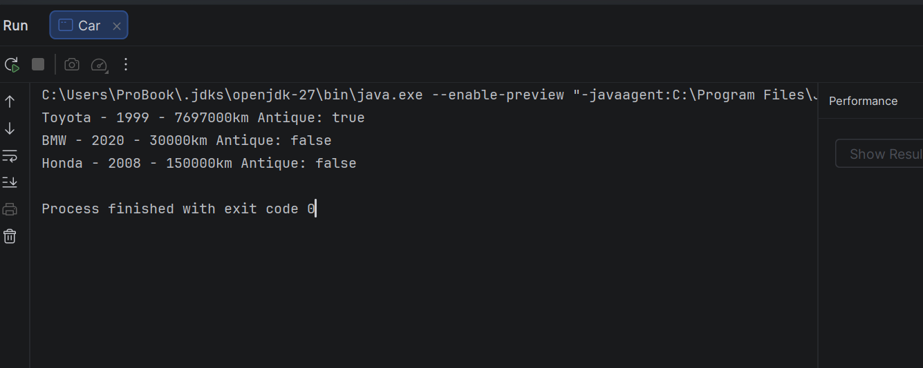

QUESTION 3
public class Rectangle {
double width;
double height;
double area() {
return width * height;
}
double perimeter() {
return 2 * (width + height);
}
public static void main(String[] args) {
Rectangle[] rects = new Rectangle[5];
//create 5 rectangles
for (int i = 0; i < 5; i++) {
rects[i] = new Rectangle();
rects[i].width = i + 2;
rects[i].height = i + 3;
}
Rectangle largest = rects[0];
for (Rectangle r : rects) {
if (r.area() > largest.area()) {
largest = r;
}
}
System.out.println("Largest area:" + largest.area());
}
}

OUTPUT
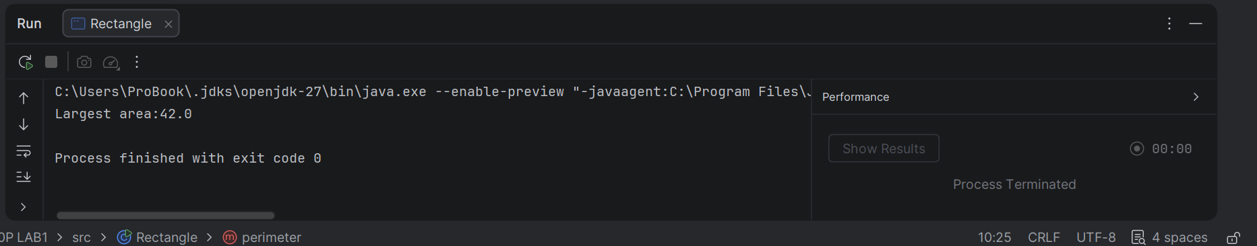

QUESTION 4 CODE
public class Rectangle {
double width;
double height;
double area() {
return width * height;
}
double perimeter() {
return 2 * (width + height);
}
public static void main(String[] args) {
Rectangle[] rects = new Rectangle[5];
//create 5 rectangles
for (int i = 0; i < 5; i++) {
rects[i] = new Rectangle();
rects[i].width = i + 2;
rects[i].height = i + 3;
}
Rectangle largest = rects[0];
for (Rectangle r : rects) {
if (r.area() > largest.area()) {
largest = r;
}
}
System.out.println("Largest area:" + largest.area());
Rectangle r1 = new Rectangle();
r1.width = 10;
r1.height = 5;
Rectangle r2 = r1; //Not a copy!
r2.width = 99;
System.out.println(r1.width); //what prints ?
}
}

OUTPUT
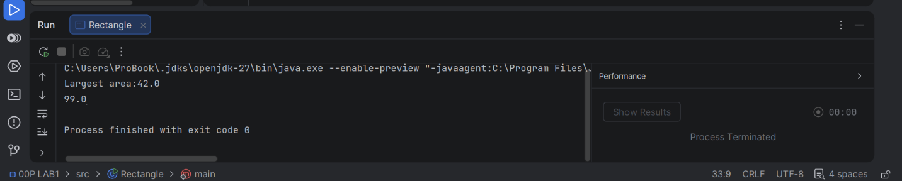

QUESTION 5
ADRESS CODE
public class Adress {
String city;
String street;
}

PERSON CODE

public class Person {
String name;
Adress adress;
//Person Has An Adress
public static void main(String[] args){
Person p1 = new Person();
p1.name = "Tendai";
p1.adress = new Adress();
p1.adress.city = "Harare";
//chained dot expression
System.out.println(p1.adress.city);//works:prints Harare
Person p2 = new Person();
p2.name = "Rudo";
p2.adress = null;
//no adress set
//This will CRASH
//system.out.println(p2.adress .city);
//->Null pointerException:cannot read field"city" because"p2.adress"is null
}
}

OUTPUT

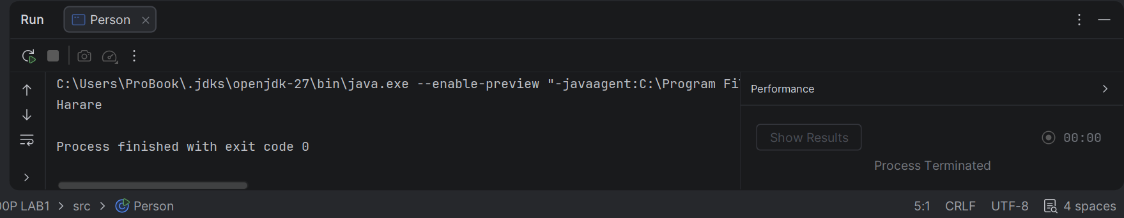

LAB 2
QUESTION 1

public class Circle {
private double radius;
//Constructor taking the radius
public Circle (double radius ){
this.radius = radius;//this.radius = field,radius = parameter
}
// No argument constructor:defaults the radius to 1.0
public Circle() {
this(1.0); //calls the constructor above ;must be first statement
}
public double getRadius(){
return radius;
}
public static void main(String[]args){
Circle c1 = new Circle(5.5);
Circle c2 = new Circle(); //uses the default radius
System.out.println("c1 radius: " + c1.getRadius());//5.5
System.out.println("c2 radius: " + c2.getRadius ());//1.0
}
}

OUTPUT

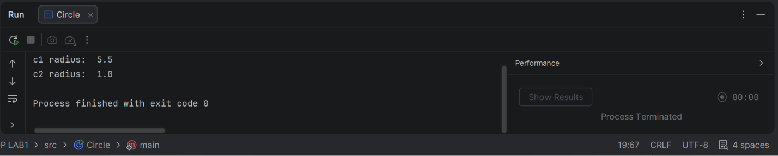

QUESTION 2 CODE
public class Circle {
private double radius;
//Constructor taking the radius
public static int count =0;
public Circle (double radius ){
this.radius = radius;//this.radius = field,radius = parameter
count++;
}
// No argument constructor:defaults the radius to 1.0
public Circle() {
this(1.0); //calls the constructor above ;must be first statement
}
public static int getCount(){
return count;
}
public double getRadius(){
return radius;
}
public static void main(String[]args){
Circle c1 = new Circle(5.5);
Circle c2 = new Circle();
Circle c3 = new Circle(2.0);
System.out.println("c1 radius: " + c1.getRadius());//5.5
System.out.println("c2 radius: " + c2.getRadius ());//1.0
System.out.println("c3 radius: " + c3.getRadius ());//2.0
//called on the class itself ,not an object
System.out.println("circles created: " + Circle.getCount());//3
}
}

OUTPUT
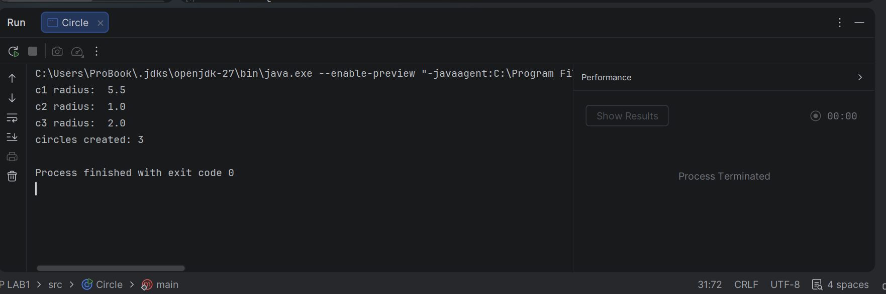
QUESTION 3
public class Employee {
//static: //shared by all employees,holds the NEXT id to hand out
private static int nextId = 1;
private final int employeeId; //final:assigned once ,never changed
private String name;
private double salary;
private String department;
//Main constructor:the other constructors end up calling this one
public Employee(String name, double salary, String department) {
this.employeeId = nextId++;
this.name = name;
this.salary = salary;
this.department = department;
}
//Overloaded constructor 2: default department
public Employee(String name, double salary) {
this(name, salary, "General");//must be the first statement
}
//Overloaded constructor 3:name only ,default salary
public Employee(String name) {
this(name, 0.0);
}
//copy constructor: independent object with the same values.
//It gets its own new id so ids stay unique.
public Employee(Employee other) {
this(other.name, other.salary, other.department);
}
@Override
public String toString() {
return "Employee{id=" + employeeId + ",name=" + name + ",salary=" + salary + ",dept=" + department + "}";
}
public static void main(String[] args) {
Employee e1 = new Employee("Faith", 5000, "IT");
Employee e2 = new Employee("Merit", 7000);
Employee e3 = new Employee("Tapiwa");
Employee e4 = new Employee(e1); //copy of e1,different id
System.out.println(e1);
System.out.println(e2);
System.out.println(e3);
System.out.println(e4);
System.out.println("e1 == e4" + (e1 == e4)); //false: seperate objects
}
}
OUTPUT
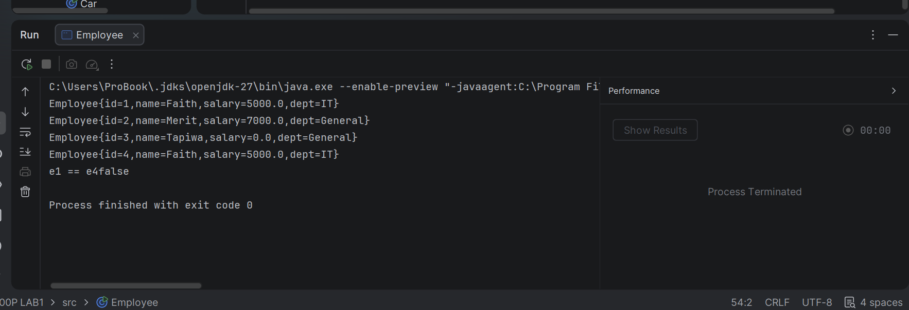

QUESTION 4
public class InitOrder {
//Field initializer: runs as part of instance initialisation in written order
int value= log("instance field");
static {
System.out.println("static block 1");
}
{
System.out.println("instance block 1");
}
static {
System.out.println("static block 2");
}
{
System.out.println("instance block 2");
}
public InitOrder(){
System.out.println("constructor"); //runs After the instance parts
}
static int log(String message){
System.out.println(message);
return 0;
}
public static void main(String[]args){
System.out.println("---first object---");
new InitOrder();
System.out.println("---second object---");
new InitOrder();
}
}

OUTPUT
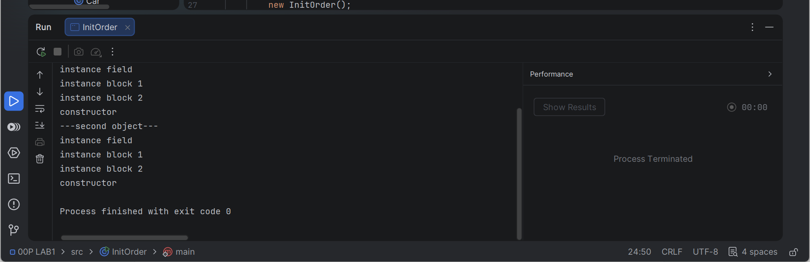

QUESTION 5
public class Temperature {
private final double celsius; //always stored in Celsius
//private constructor: outside code cannot call new Temperature(...)
private Temperature(double celsius){
if (celsius< -273.15){
throw new IllegalArgumentException("Below absolute zero:" + celsius);
}
this.celsius = celsius;
}
//static factory: the name says what the number means
public static Temperature fromCelsius(double c){
return new Temperature(c);
}
//static factory: converts Fahrenheit to celsius first
public static Temperature fromFahrenheit(double f){
return new Temperature((f-32)*5/9);
}
public double getCelsius() {
return celsius ;
}
public double getFahrenheit(){
return celsius * 9 / 5 + 32;
}
@Override
public String toString(){
return String.format("%.1f C = %.1f F" , getCelsius(),getFahrenheit());
}
public static void main(String[]args){
Temperature t1 = Temperature.fromCelsius(25);
Temperature t2 = Temperature.fromFahrenheit(212);
System.out.println(t1);
System.out.println(t2);
}
}

OUTPUT
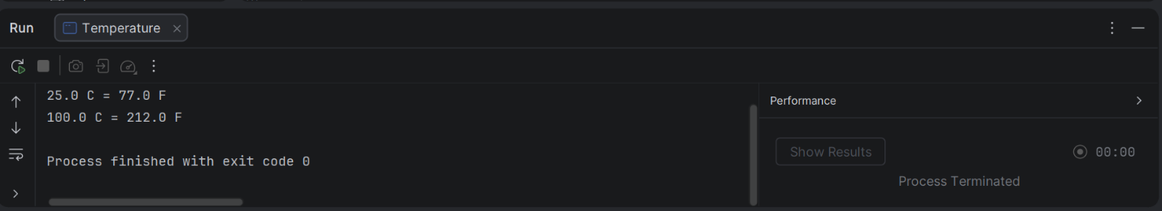

LAB 3
QUESTION 1 CODE
public class Student {
private String name;
private int marks;
//the constructor calls the setters ,so validation happens in one place
public Student(String name, int marks){
setName(name);
setMarks(marks);
}
public String getName(){
return name;
}
public void setName(String name) {
if(name == null || name.isBlank()){
throw new IllegalArgumentException("Name cannot be empty");
}
this.name = name;
}
public int getMarks(){
return marks;
}
//Rejects any mark outside 0 to 100
public void setMarks(int marks) {
if(marks<0 || marks>100){
throw new IllegalArgumentException("Marks must be between 0 and 100,got"+marks);
}
this.marks = marks;
}
@Override
public String toString(){
return name + ";" + marks;
}
public static void main(String[]args){
Student s = new Student("Merit",75);
System.out.println(s);
try{
s.setMarks(120);//invalid
}
catch(IllegalArgumentException e){
System.out.println("Rejected:" + e.getMessage());
}
System.out.println("Marks are still" + s.getMarks());
try{
new Student("Faith", -5);
}
catch(IllegalArgumentException e){
System.out.println("Rejected:" + e.getMessage());
}
}
}

OUTPUT
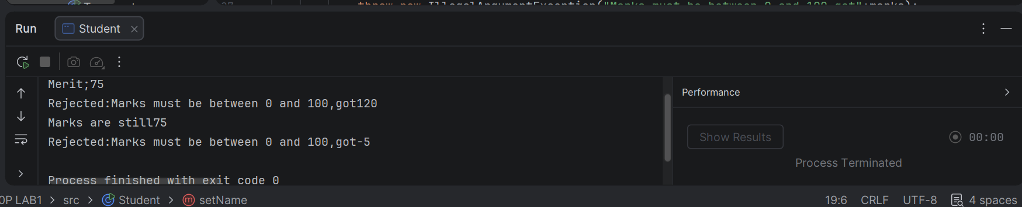

QUESTION 2
public class Student {
private String name;
private int marks;
//the constructor calls the setters ,so validation happens in one place
public Student(String name, int marks){
setName(name);
setMarks(marks);
}
public String getName(){
return name;
}
public void setName(String name) {
if(name == null || name.isBlank()){
throw new IllegalArgumentException("Name cannot be empty");
}
this.name = name;
}
public int getMarks(){
return marks;
}
public char getGrade(){
if(marks >= 75) return'A';
if(marks >= 65) return'B';
if(marks >= 50) return'C';
return 'F';
}
//Rejects any mark outside 0 to 100
public void setMarks(int marks) {
if(marks<0 || marks>100){
throw new IllegalArgumentException("Marks must be between 0 and 100,got"+marks);
}
this.marks = marks;
}
@Override
public String toString(){
return name + ":" + marks + "(" + getGrade() +")";
}
public static void main(String[]args){
Student s = new Student("Merit",75);
System.out.println(s);
s.setMarks(68);
System.out.println(s);
s.setMarks(55);
System.out.println(s);
s.setMarks(30);
System.out.println(s);
}
}
OUTPUT
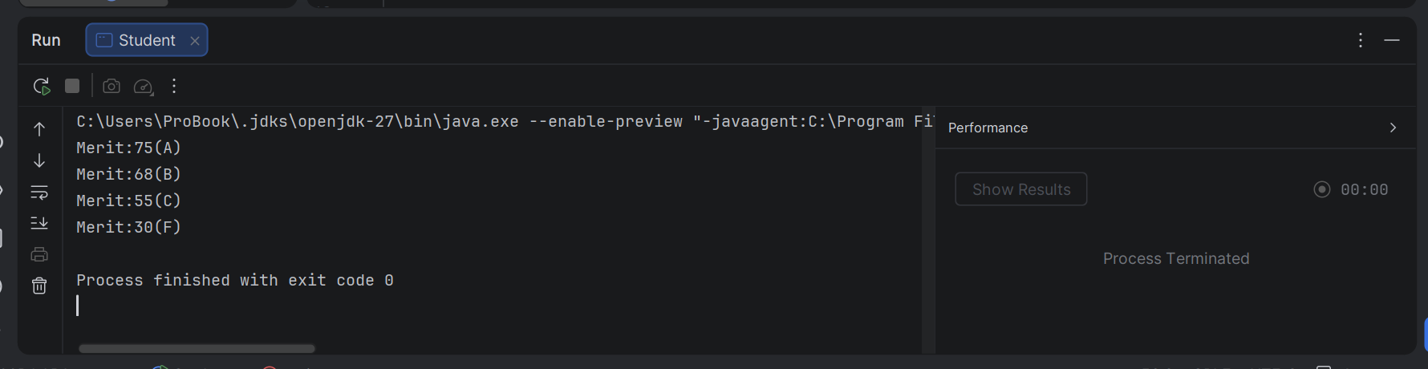

QUESTION 3
import java.util.List;
import java.util.ArrayList;
import java.util.Collections;
public class BankAccount {
private double balance;
private List<String> history = new ArrayList<>(); //private so no outside access
public void deposit(double amount){
balance += amount;
history.add("Deposited " + amount); //record each transaction
}
//Unmodified COPY:callers can read it but cannot change it
public List<String> getHistory(){
return Collections.unmodifiableList(new ArrayList<>(history));
}
public static void main(String[] args){
BankAccount acc = new BankAccount();
acc.deposit(500);
System.out.println(acc.getHistory()); //Deposited 500
try{
acc.getHistory().add("Hacked"); //blocked
} catch (UnsupportedOperationException e) {
System.out.println("History cannot be modified");
}
}
}

OUTPUT
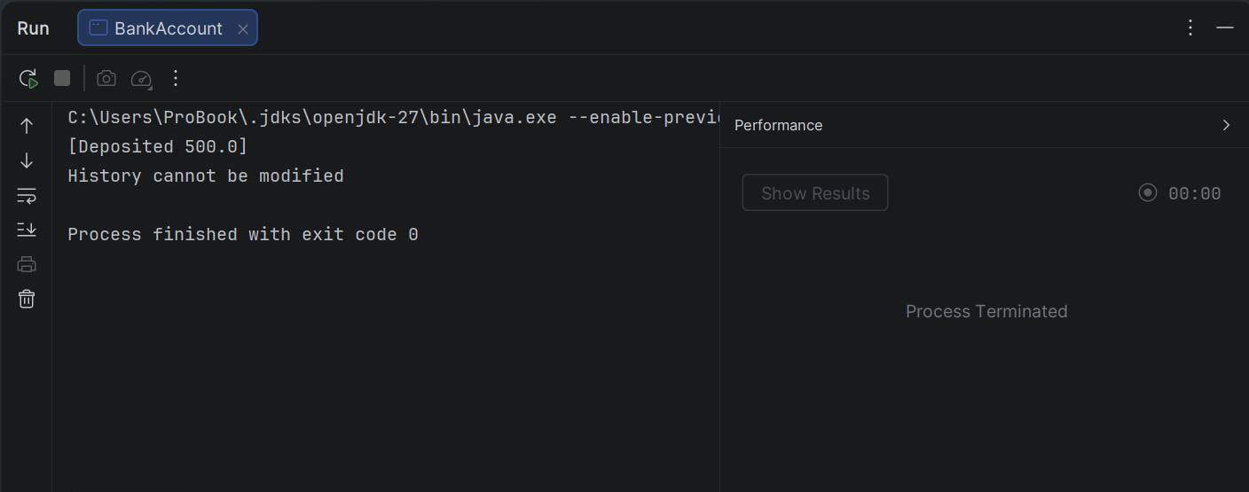

QUESTION 4

public class ImmutablePerson {
//private final fields :assigned once in the constructor,never changed
private final String name;
private final int age;
public ImmutablePerson(String name, int age){
this.name = name;
this.age = age;
}
//Getters only,no setters
public String getName() {
return name;
}
public int getAge() {
return age;
}
public static void main(String[] args){
ImmutablePerson p = new ImmutablePerson("Merit", 21);
System.out.println(p.getName() + " , " + p.getAge()); //Merit 21
}
}

OUTPUT
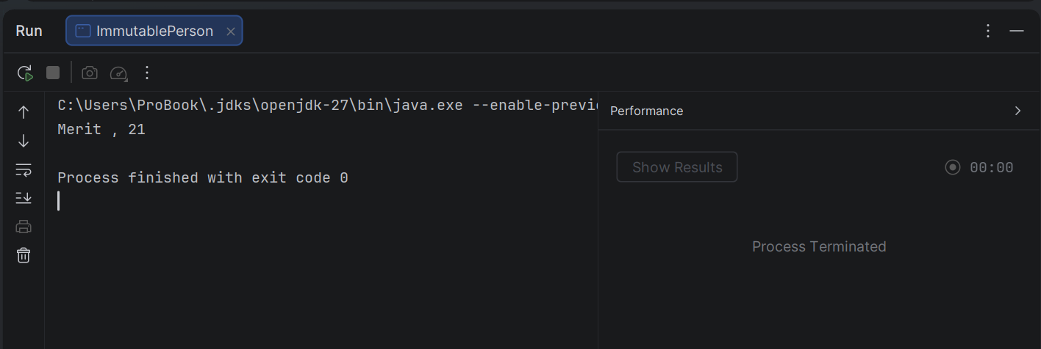

QUESTION 5
public class Temperature2 {
//internal unit is kevin.It is private ,so callers never see it
private final double kelvin;
public Temperature2(double kelvin){
//Reject values below absolute zero(0 k)
if(kelvin<0){
throw new IllegalArgumentException("Below absolute zero: " + kelvin);
}
this.kelvin = kelvin;
}
public double getCelsius(){
return kelvin -273.15;
}
public double getFahrenheit(){
return getCelsius() * 9 / 5 + 32;
}
public static void main(String[] args){
Temperature2 t = new Temperature2(300);
System.out.println(t.getCelsius()); //26.850000000000023
System.out.println(t.getFahrenheit()); //80.3300000000004
try{
new Temperature2(-5); //invalid rejected
} catch (IllegalArgumentException e) {
System.out.println("Rejected: " + e.getMessage());
}
}
}

OUTPUT
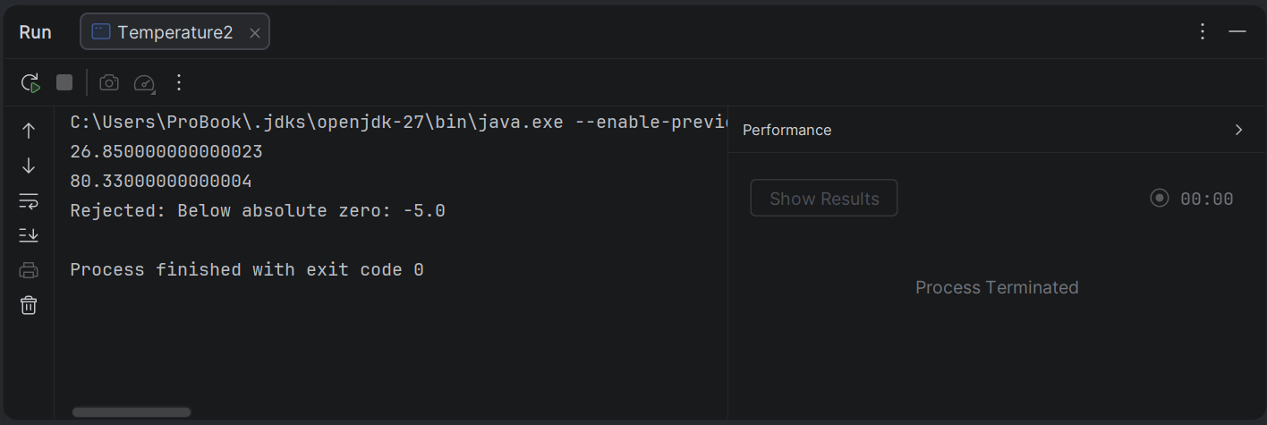

LAB 4

QUESTION 1
class Person5 {
String name;
int age;
Person5(String name, int age){
this.name = name;
this.age = age;
}
void display(){
System.out.println("Name: " + name + ",Age: " + age);
}
}
class Student5 extends Person5{
String course;
Student5(String name, int age, String course){
super(name, age);
this.course=course;
}
}
class Persons{
public static void main (String[] args){
Person5 p = new Person5("Merit",30);
Student5 s = new Student5("Mellisa",20,"OOP");
p.display();
s.display();
System.out.println("Course:" + s.course);
}
}

OUTPUT

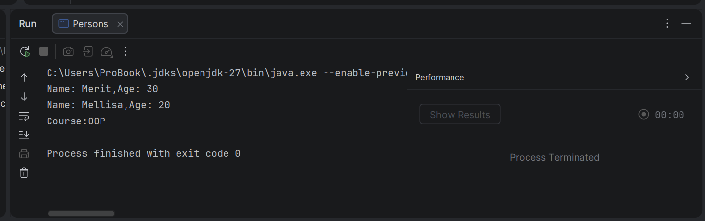

QUESTION 2
class Person5 {
String name;
int age;
Person5(String name, int age){
this.name = name;
this.age = age;
}
void display(){
System.out.println("Name: " + name + ",Age: " + age);
}
}
class Student5 extends Person5{
String course;
Student5(String name, int age, String course){
super(name, age);
this.course=course;
}
}
class Teacher5 extends Person5{
String subject;
Teacher5(String name,int age ,String subject){
super(name, age); //refuses the Person5 constructor
this.subject = subject;
}
}
class Person5Demo{
public static void main (String[] args){
Teacher5 t = new Teacher5("Merit",30 , "JAVA");
Student5 s = new Student5("Mellisa",20,"OOP");
//Both call the SAME display () method which is written once in Person5
t.display(); // Name:Merit , Age:30
s.display(); // Name:Mellisa , Age:20
System.out.println("Course:" + s.course); //Course:OOP
System.out.println("Subject:" + t.subject); //Subject:JAVA
}
}

OUTPUT
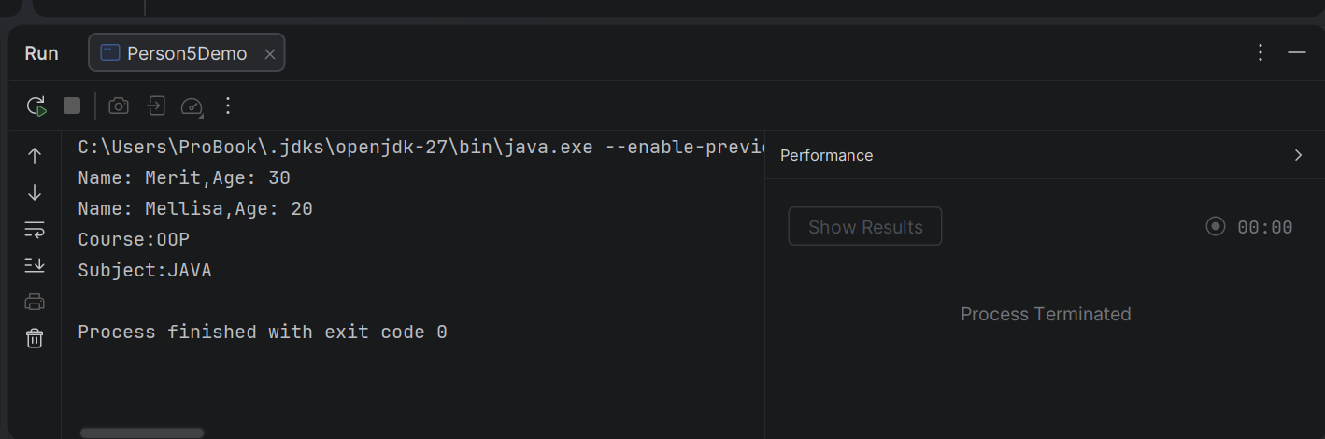

QUESTION 3
public class Vehicle4 {
Vehicle4(){
System.out.println("1. Vehicle constructor");
}
}
class Car4 extends Vehicle4{
Car4(){
//Java inserts super()here automatically, so Vehicle4 runs first
System.out.println("3. ElectricCar constructor");
}
}
class ElectricCar4 extends Car4{
ElectricCar4(){
//Java inserts super () here automatically,so Vehicle4 runs next
System.out.println("3. ElectricCar constructor");
}
}
class ConstructorOrder{
public static void main(String[] args){
new ElectricCar4();
}
}

OUTPUT
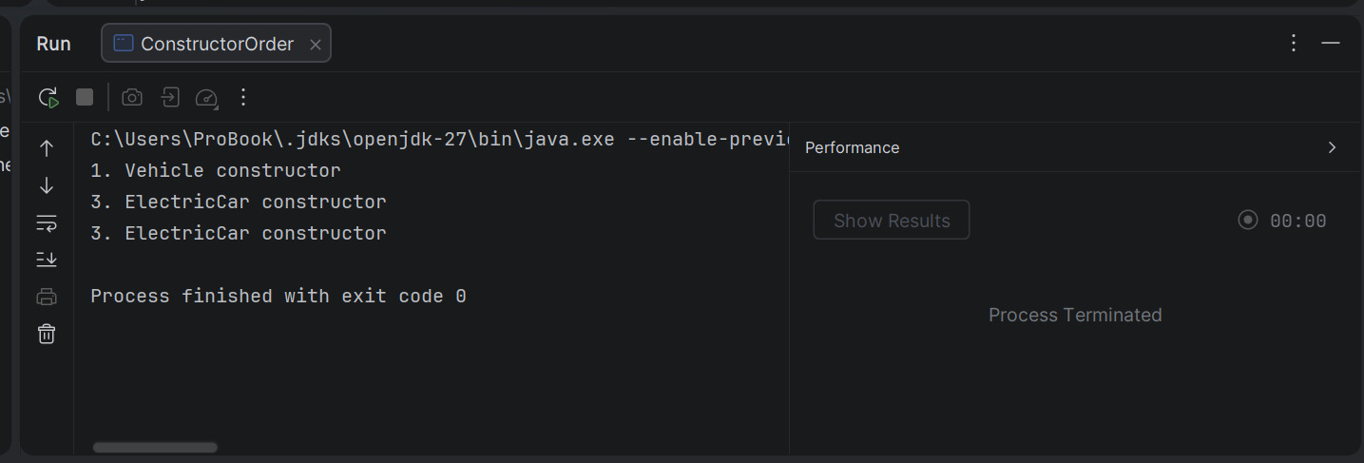

QUESTION 4
public class Animal5 {
String name;
//Only a constructor with a parameter: Java does NOT create a default one
Animal5(String name){
this.name=name;
}
}
//FAILS TO COMPLETE
//Class Dod5 extends Animal5{
//Dod5() //Java inserts super() automatically,nut Animal5 has no
//} //no-arguement constructor->compile error
//FIX: Call the Animal5 constructor yourself with super(name)
class Dog5 extends Animal5{
Dog5(String name){
super(name); //must be the first statement
}
}
class AnimalDemo{
public static void main(String[] args){
Dog5 d = new Dog5( "Tiger");
System.out.println("Dog name:" + d.name ); //Dog name:Tiger
}
}

OUTPUT
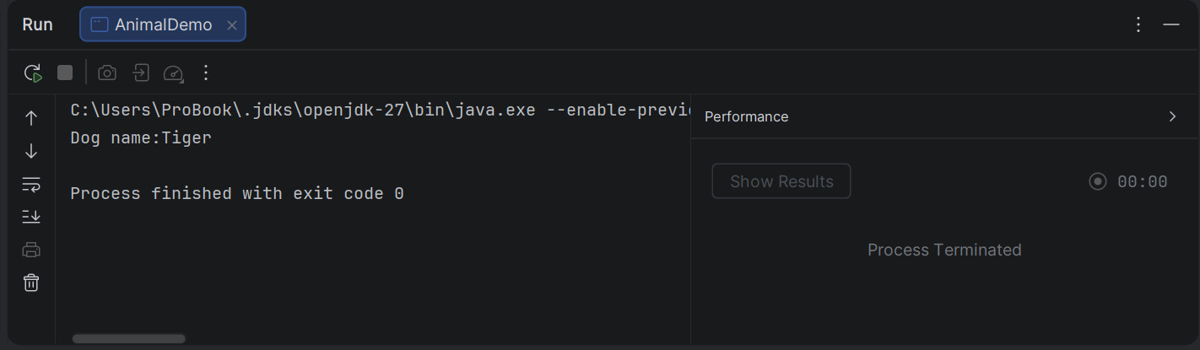

QUESTION 5
import java.util.ArrayList;
//Before (inheritance): class Stack extends Arraylist<String>{....}
//It wrongly exposes add(index ,X) ,remove (index),get(i),set(....),clear()
//AFTER (composition): a stack HAS-A list
public class Stack {
private final ArrayList<String> items = new ArrayList<>(); //hidden
public void push(String item){items.add(item);}
public String pop(){return items.remove(items.size() -1);}
public static void main(String[] args){
Stack s =new Stack();
s.push("A");
s.push("B");
System.out.println(s.pop()); //B
System.out.println(s.pop()); //A
//s.add(0,"X" ; //compile error: Stack has no add() method
}
}

OUTPUT
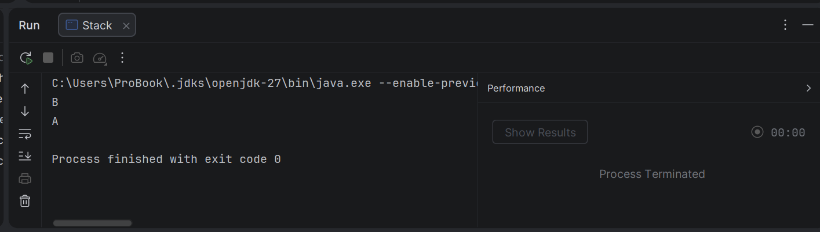

LAB 5
QUESTION 1
import java.util.Arrays;
public class PrintDemo {
//overloading: same method name,different parameter types
//called when the arguement is an int
static void print(int x) {
System.out.println("int: " + x);
}
//called when the arguement is a double
static void print(double x) {
System.out.println("double: " + x);
}
//called when the arguement is a string
static void print(String x) {
System.out.println("String: " + x);
}
//called when the arguement is an int array
static void printt(int[] x){
System.out.println("int[]:" + Arrays.toString(x));
}
public static void main(String[]args){
print(5); //int version chosen
print(3.14); //double version chosen
print("Hello"); //string version chosen
printt(new int[]{1,2,3}); //int[] version chosen
}
}

OUTPUT
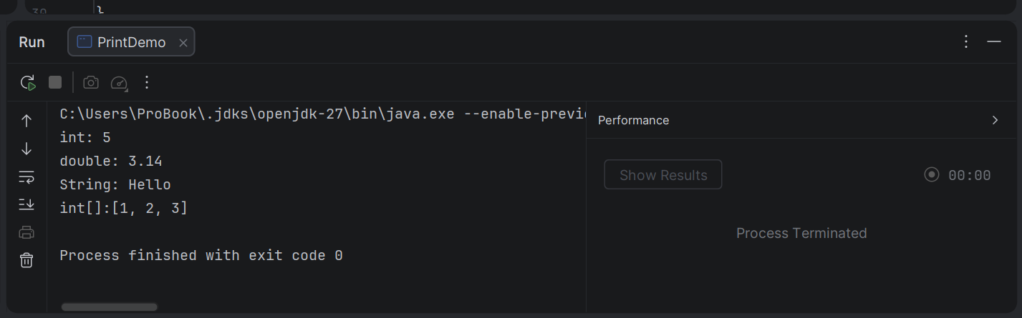

QUESTION 2
public class Animal {
public void sound(){
System.out.println("Some generic animal sound");
}
}
//Each subclass overrides sound () with its own behaviour
class Cat extends Animal{
@Override //checks that we really are overriding the superclass method
public void sound() {
System.out.println("Meow");
}
}
class Cow extends Animal{
@Override
public void sound(){
System.out.println("Mooo");
}
}
class Duck extends Animal{
@Override
public void sound(){
System.out.println("Quack");
}
}
class AnimalDemo{
public static void main(String[] args){
//One array of the superclass type can hold any subclass object
Animal[] animals = {new Cat(), new Cow(), new Duck()};
for (Animal a : animals){
a.sound(); //runtime type decides which version runs(polymorphism)
}
}
}
OUTPUT
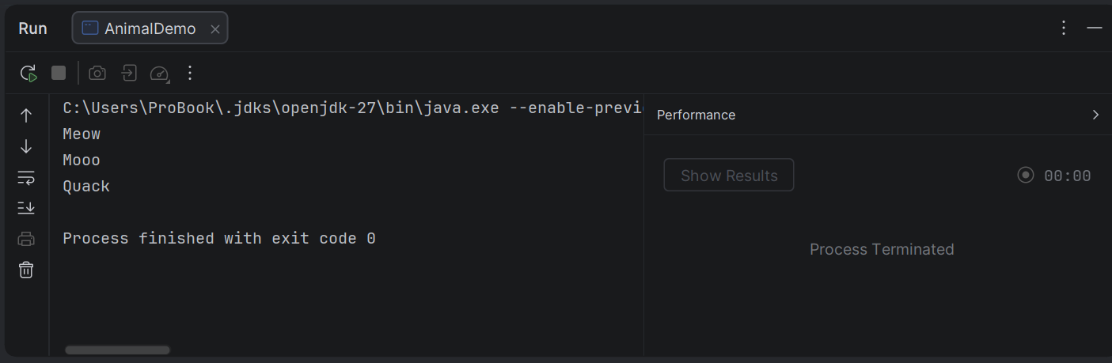

QUESTION 3
import java.awt.*;
public class Employee2 {
private String name;
private double baseSalary;
public Employee2(String name,double baseSalary){
this.name =name;
this.baseSalary= baseSalary;
}
public String getName() {
return name;
}
public double getBaseSalary() {
return baseSalary;
}
// Subclasses override this to change how pay is worked out
public double calculatePay(){
return baseSalary;
}
}
//Existing subclass: salary plus a bonus
class Manager extends Employee2{
private double bonus;
public Manager(String name,double baseSalary,double bonus){
super(name, baseSalary);
this.bonus = bonus;
}
@Override
public double calculatePay(){
return getBaseSalary() + bonus;
}
}
class Intern extends Employee2{
private double hourlyRate;
private int hoursWorked;
public Intern(String name, double hourlyRate,int hoursWorked){
super(name, 0);
this.hourlyRate = hourlyRate;
this.hoursWorked = hoursWorked;
}
@Override
public double calculatePay(){
return hourlyRate*hoursWorked;
}
}
class PayrollDemo{
public static void main(String[] args){
Employee2[] staff ={
new Employee2("Tapiwa",1000),
new Manager("Viola",2000,500),
new Intern("Faith",200,30),
};
double total=0;
for(Employee2 e : staff){
double pay =e.calculatePay(); //the actual object's version runs
System.out.println(e.getName() + ":" + pay);
total += pay;
}
System.out.println("Total payroll:" + total);
}
}

OUTPUT
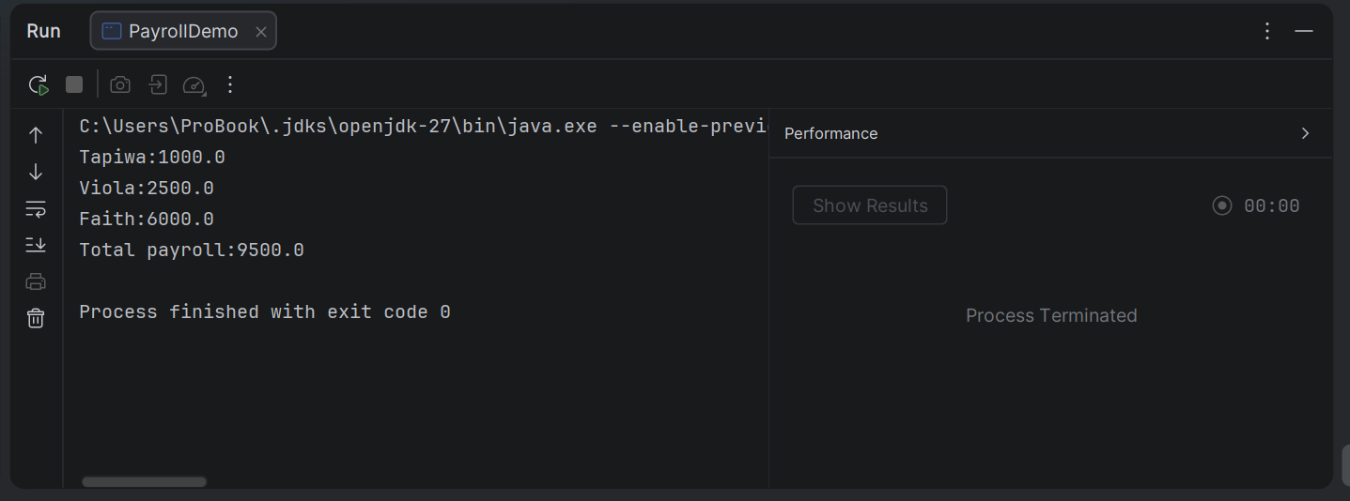
QUESTION 4
public class Base {
String name = "Base field";
void show(){
System.out.println("Base method");
}
}
class Derived extends Base{
String name ="Derived field"; //hides the field (does not override it)
@Override
void show(){
System.out.println("Derived method");
}
}
class FieldVsMethod{
public static void main(String[] args){
Base b = new Derived(); //superclass reference ,subclass object
b.show(); //method:Derived method
System.out.println(b.name); //field:Base field
System.out.println(((Derived)b).name); //cast: Derived field
}
}

OUTPUT
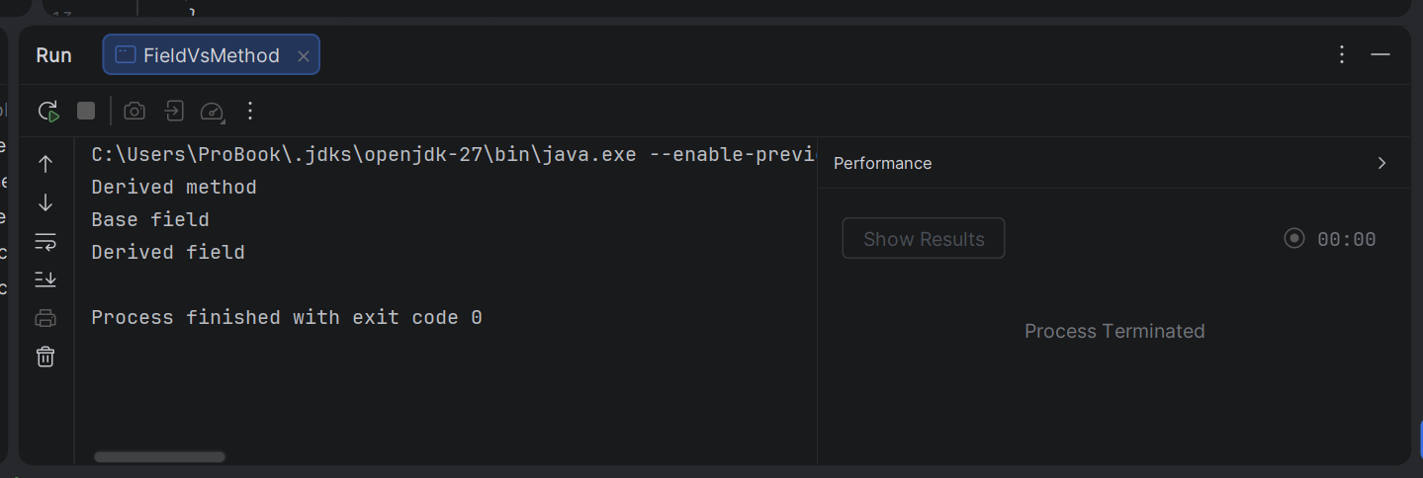

QUESTION 5
abstract class Payment {
protected double amount;
Payment(double amount){this.amount = amount;}
abstract void process(); //each payment type supplies its own behaviour
}
class CardPayment extends Payment{
public CardPayment(){
super(0);
}
@Override
public void process(){
System.out.println("Card processed");
}
}
class MobileMoneyPayment extends Payment{
public MobileMoneyPayment (){
super(0);
}
@Override
public void process(){
System.out.println("Mobile money processed");
}
}
class PaymentProcessor{
static void pay(Payment p){
p.process();
}
}
class PaymentDemo{
public static void main(String[] args){
Payment p1= new CardPayment();
Payment p2 = new MobileMoneyPayment();
PaymentProcessor.pay(p1);
PaymentProcessor.pay(p2);
}
}

OUTPUT
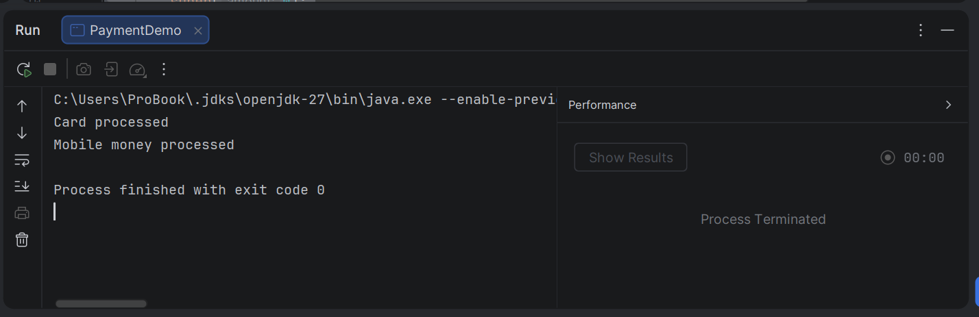

LAB 6
QUESTION 1

// Shape.java
public abstract class Shape {
public abstract double area();
public abstract double perimeter();
@Override
public String toString() {
return getClass().getSimpleName()
+ " [area=" + String.format("%.2f", area())
+ ", perimeter=" + String.format("%.2f", perimeter()) + "]";
}
}
// Circle.java
class Circle2 extends Shape {
private final double radius;
public Circle2(double radius) {
this.radius = radius;
}
@Override
public double area() {
return Math.PI * radius * radius;
}
@Override
public double perimeter() {
return 2 * Math.PI * radius;
}
}
// Rectangle.java
class Rectangle2 extends Shape {
protected final double length;
protected final double width;
public Rectangle2(double length, double width) {
this.length = length;
this.width = width;
}
@Override
public double area() {
return length * width;
}
@Override
public double perimeter() {
return 2 * (length + width);
}
}
// Square.java
class Square extends Rectangle2 {
public Square(double side) {
super(side, side);
}
}
// Main.java
class Main {
public static void main(String[] args) {
Shape[] shapes = {
new Circle2(5),
new Rectangle2(4, 6),
new Square(3)
};
for (Shape s : shapes) {
System.out.println(s);
}
}
}

OUTPUT
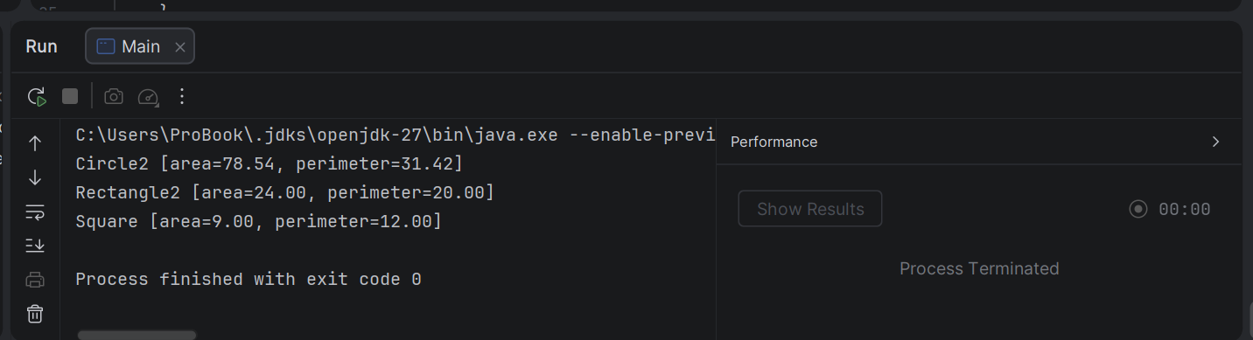
QUESTION 2
// Flyable.java
public interface Flyable {
void fly();
}
// Bird.java
class Bird implements Flyable {
private final String name;
public Bird(String name) {
this.name = name;
}
@Override
public void fly() {
System.out.println(name + " the bird flaps its wings and takes off.");
}
}
// Aeroplane.java
class Aeroplane implements Flyable {
private final String model;
public Aeroplane(String model) {
this.model = model;
}
@Override
public void fly() {
System.out.println("The " + model + " aeroplane spins its engines and takes off.");
}
}
// Main.java
class FlyDemo {
public static void main(String[] args) {
Flyable[] flyers = {
new Bird("Eagle"),
new Aeroplane("Boeing 737")
};
for (Flyable f : flyers) {
f.fly();
}
}
}

OUTPUT
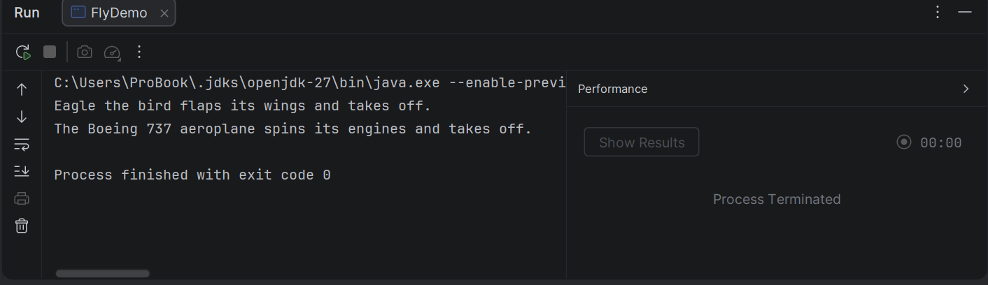

QUESTION 3
// Account.java
public abstract class Account {
private final String accountNumber;
protected double balance;
public Account(String accountNumber, double initialBalance) {
this.accountNumber = accountNumber;
this.balance = initialBalance;
}
// Concrete method: shared by all account types
public void deposit(double amount) {
if (amount <= 0) {
throw new IllegalArgumentException("Deposit must be positive.");
}
balance += amount;
}
// Abstract method: each account type defines its own fee
public abstract double monthlyFee();
// Applies the fee to the balance
public void applyMonthlyFee() {
balance -= monthlyFee();
}
public String getAccountNumber() {
return accountNumber;
}
public double getBalance() {
return balance;
}
@Override
public String toString() {
return getClass().getSimpleName() + " " + accountNumber
+ " [balance=" + String.format("%.2f", balance)
+ ", monthlyFee=" + String.format("%.2f", monthlyFee()) + "]";
}
}
// SavingsAccount.java
class SavingsAccount extends Account {
private static final double FEE = 2.50;
public SavingsAccount(String accountNumber, double initialBalance) {
super(accountNumber, initialBalance);
}
@Override
public double monthlyFee() {
return FEE;
}
}
// CurrentAccount.java
class CurrentAccount extends Account {
private static final double BASE_FEE = 10.00;
private static final double FEE_WAIVER_BALANCE = 1000.00;
public CurrentAccount(String accountNumber, double initialBalance) {
super(accountNumber, initialBalance);
}
// Fee is waived if the balance is high enough
@Override
public double monthlyFee() {
return balance >= FEE_WAIVER_BALANCE ? 0.0 : BASE_FEE;
}
}
// Main.java
class AccountDemo{
public static void main(String[] args) {
Account[] accounts = {
new SavingsAccount("SAV-001", 500),
new CurrentAccount("CUR-001", 800),
new CurrentAccount("CUR-002", 2000)
};
for (Account a : accounts) {
a.deposit(100);
System.out.println("Before fee: " + a);
a.applyMonthlyFee();
System.out.println("After fee: " + a);
System.out.println();
}
}
}

OUTPUT
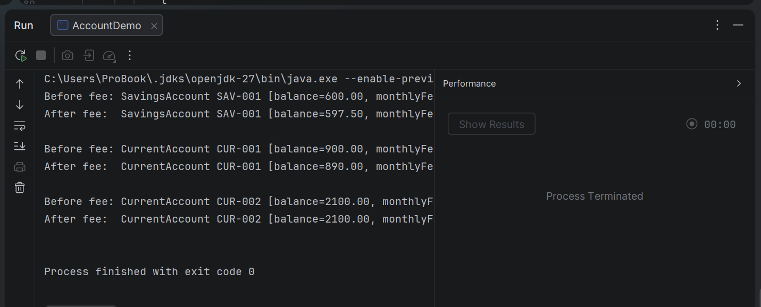

QUESTION 4
import java.util.Collections;
import java.util.ArrayList;
import java.util.Collections;
import java.util.List;
import java.util.Comparator;
// Student.java
public class Student4 implements Comparable<Student4> {
private final String name;
private final double marks;
public Student4(String name, double marks) {
this.name = name;
this.marks = marks;
}
public String getName() {
return name;
}
public double getMarks() {
return marks;
}
// Natural ordering: alphabetical by name
@Override
public int compareTo(Student4 other) {
return this.name.compareToIgnoreCase(other.name);
}
@Override
public String toString() {
return name + " (" + marks + ")";
}
}
// MarksComparator.java
class MarksComparator implements Comparator<Student4> {
// Highest marks first
@Override
public int compare(Student4 a, Student4 b) {
return Double.compare(b.getMarks(), a.getMarks());
}
}
// Main.java
class Student4Demo {
public static void main(String[] args) {
List<Student4> students = new ArrayList<>();
students.add(new Student4("Tendai", 72.5));
students.add(new Student4("Alice", 88.0));
students.add(new Student4("Rudo", 65.0));
students.add(new Student4("Brian", 88.0));
// 1. Natural order (Comparable): by name
Collections.sort(students);
System.out.println("Sorted by name:");
students.forEach(System.out::println);
// 2. Custom order (Comparator): by marks, highest first
Collections.sort(students, new MarksComparator());
System.out.println("\nSorted by marks (descending):");
students.forEach(System.out::println);
// 3. Same thing using a lambda
students.sort((a, b) -> Double.compare(a.getMarks(), b.getMarks()));
System.out.println("\nSorted by marks (ascending, lambda):");
students.forEach(System.out::println);
}
}

OUTPUT
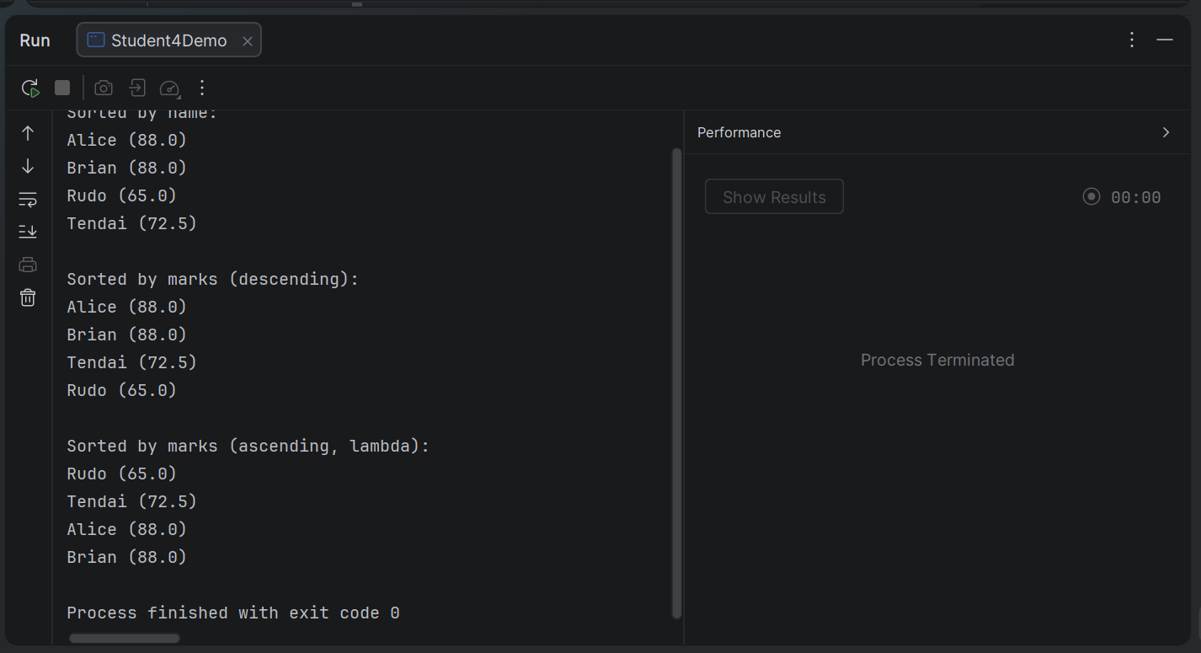

QUESTION 5
// English.java
interface English {
default void hello() {
System.out.println("Hello from English!");
}
}
// Shona.java
interface Shona {
default void hello() {
System.out.println("Mhoro from Shona!");
}
}
// Greeter.java
class Greeter implements English, Shona {
// Required: without this override, the class will not compile
@Override
public void hello() {
English.super.hello(); // call English's version
Shona.super.hello(); // call Shona's version
System.out.println("Hello from Greeter itself!");
}
}
// Main.java
class GreaterDemo {
public static void main(String[] args) {
Greeter g = new Greeter();
g.hello();
}
}

OUTPUT
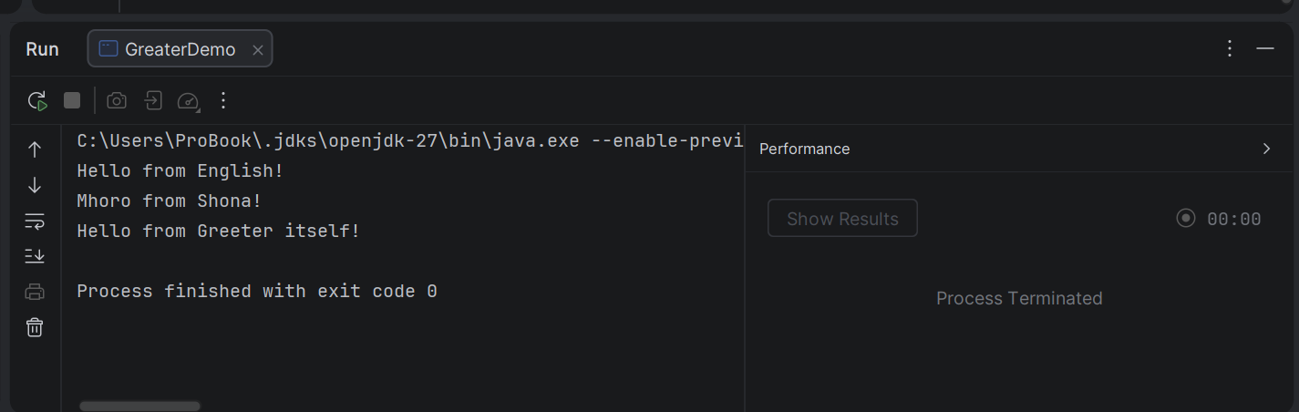

LAB 7

QUESTION 1
import java.util.InputMismatchException;
import java.util.Scanner;
class SafeDivideLoop {
private static int readInt(Scanner sc, String prompt) {
while (true) {
System.out.print(prompt);
try {
return sc.nextInt();
} catch (InputMismatchException e) {
System.out.println("That is not a whole number. Try again.");
sc.nextLine(); // discard the bad token, otherwise the loop never ends
}
}
}
public static void main(String[] args) {
Scanner sc = new Scanner(System.in);
int a = readInt(sc, "Enter the first integer: ");
int b = readInt(sc, "Enter the second integer: ");
try {
System.out.println(a + " / " + b + " = " + (a / b));
} catch (ArithmeticException e) {
System.out.println("Error: cannot divide by zero.");
}
sc.close();
}
}

OUTPUT
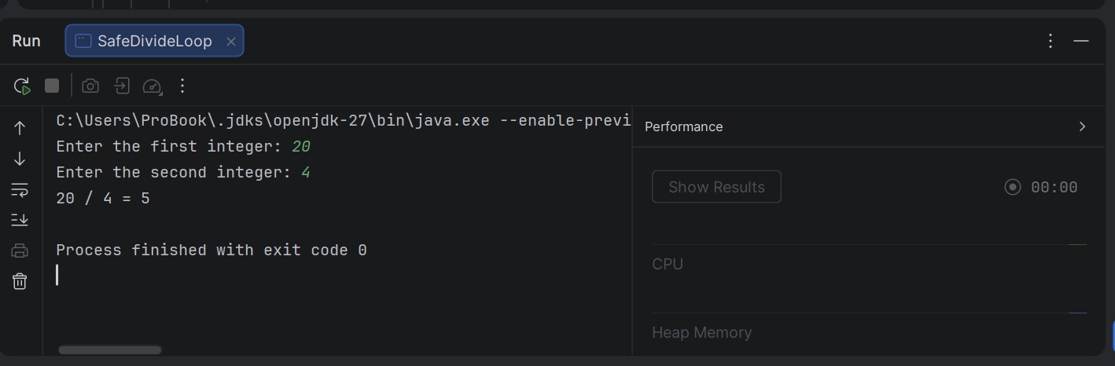

QUESTION 2
import java.util.Scanner;
public class ArrayAccess {
// Returns the element at the given index, or -1 if the index is invalid
public static int getElement(int[] arr, int index) {
try {
return arr[index]; // throws ArrayIndexOutOfBoundsException if out of range
} catch (ArrayIndexOutOfBoundsException e) {
System.out.println("Error: index " + index + " is out of bounds. "
+ "Valid indexes are 0 to " + (arr.length - 1) + ".");
return -1;
}
}
public static void main(String[] args) {
int[] numbers = {10, 20, 30, 40, 50};
System.out.println("Element at index 2: " + getElement(numbers, 2));
System.out.println("Element at index 7: " + getElement(numbers, 7));
System.out.println("Element at index -1: " + getElement(numbers, -1));
System.out.println("Program continues normally.");
}
}

OUTPUT
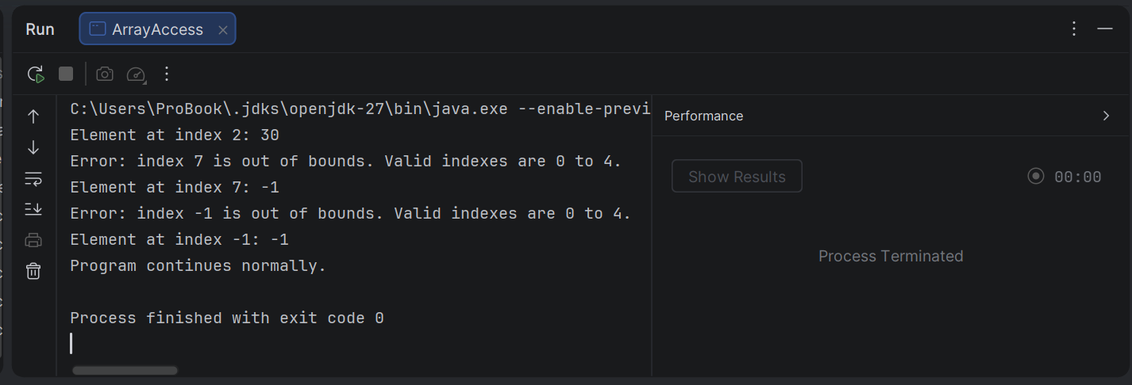

QUESTION 3
import java.util.InputMismatchException;
import java.util.Scanner;
// InvalidAgeException.java
public class InvalidAgeException extends Exception { // extends Exception = checked
private final int age;
public InvalidAgeException(int age) {
super("Invalid age: " + age + ". Age must be between 0 and 120.");
this.age = age;
}
public int getAge() {
return age;
}
}
class AgeValidator {
// "throws" is mandatory because the exception is checked
public static void validateAge(int age) throws InvalidAgeException {
if (age < 0 || age > 120) {
throw new InvalidAgeException(age);
}
System.out.println("Age " + age + " is valid.");
}
public static void main(String[] args) {
int[] testAges = {25, 0, 120, -5, 150};
for (int age : testAges) {
try {
validateAge(age);
} catch (InvalidAgeException e) {
System.out.println("Caught: " + e.getMessage());
}
}
// Interactive version
Scanner sc = new Scanner(System.in);
try {
System.out.print("\nEnter your age: ");
int age = sc.nextInt();
validateAge(age);
} catch (InvalidAgeException e) {
System.out.println("Rejected value: " + e.getAge());
System.out.println(e.getMessage());
} catch (InputMismatchException e) {
System.out.println("Please enter a whole number.");
} finally {
sc.close();
}
}
}

OUTPUT
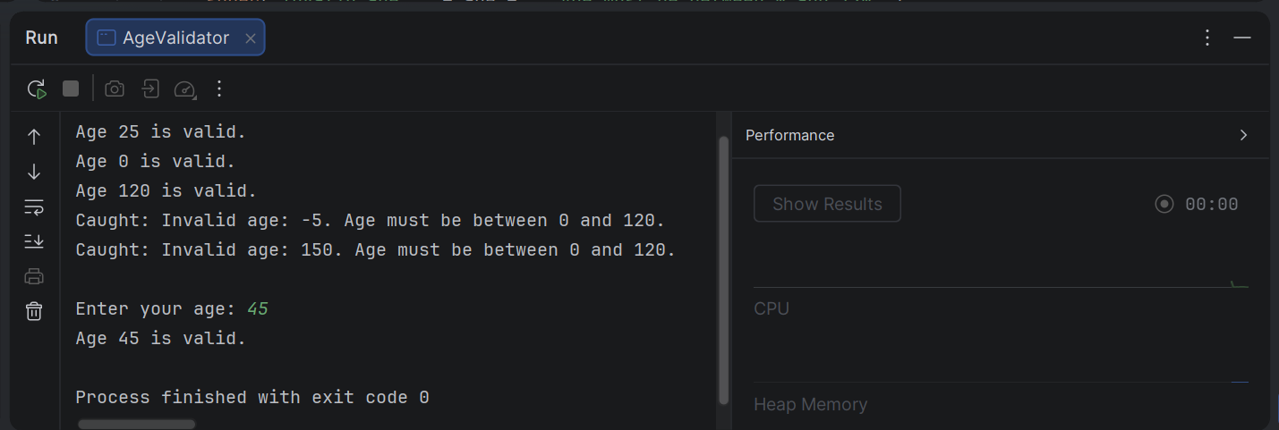
QUESTION 4
// InsufficientFundsException.java
public class InsufficientFundsException extends Exception { // checked
private final double balance;
private final double requested;
public InsufficientFundsException(double balance, double requested) {
super(String.format("Insufficient funds: balance is %.2f but %.2f was requested (short by %.2f).",
balance, requested, requested - balance));
this.balance = balance;
this.requested = requested;
}
public double getBalance() { return balance; }
public double getRequested() { return requested; }
public double getShortfall() { return requested - balance; }
}
// BankAccount.java
class BankAccount2 {
private final String accountNumber;
private String ownerName;
private double balance;
public BankAccount2(String accountNumber, String ownerName, double openingBalance) {
if (openingBalance < 0) {
throw new IllegalArgumentException("Opening balance cannot be negative");
}
this.accountNumber = accountNumber;
setOwnerName(ownerName);
this.balance = openingBalance;
}
public String getAccountNumber() { return accountNumber; }
public String getOwnerName() { return ownerName; }
public double getBalance() { return balance; }
public void setOwnerName(String ownerName) {
if (ownerName == null || ownerName.isBlank()) {
throw new IllegalArgumentException("Owner name required");
}
this.ownerName = ownerName.trim();
}
public void deposit(double amount) {
if (amount <= 0) {
throw new IllegalArgumentException("Deposit must be positive");
}
balance += amount;
}
// CHANGED: returns void and throws instead of returning boolean
public void withdraw(double amount) throws InsufficientFundsException {
if (amount <= 0) {
throw new IllegalArgumentException("Withdrawal must be positive");
}
if (amount > balance) {
throw new InsufficientFundsException(balance, amount); // state unchanged
}
balance -= amount;
}
@Override
public String toString() {
return String.format("%s [%s] balance: %.2f", accountNumber, ownerName, balance);
}
}
// BankDemo.java
class BankDemo {
public static void main(String[] args) {
BankAccount2 acc = new BankAccount2("ACC-001", "Tendai", 500.00);
acc.deposit(250.00);
System.out.println(acc);
try {
acc.withdraw(100.00);
System.out.println("Withdraw 100: success");
acc.withdraw(5000.00); // throws here
System.out.println("This line is never reached");
} catch (InsufficientFundsException e) {
System.out.println("Withdraw failed: " + e.getMessage());
System.out.println("Shortfall: " + e.getShortfall());
}
System.out.println(acc);
try {
acc.deposit(-50);
} catch (IllegalArgumentException e) {
System.out.println("Rejected: " + e.getMessage());
}
}
}

OUTPUT
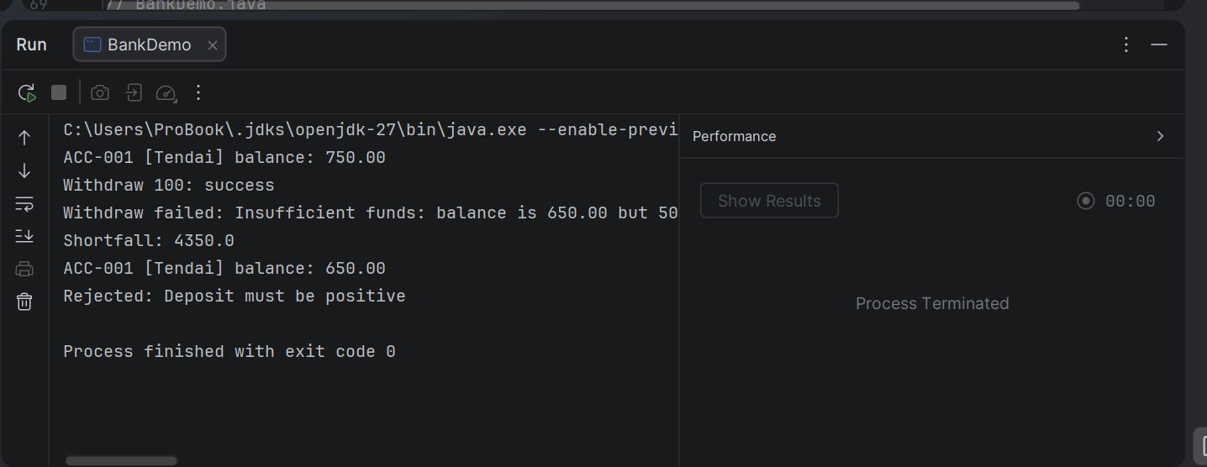

QUESTION 5
public class FinalDemo {
// 1. The basic case from the exercise
static int basic() {
try {
System.out.println("basic: in try");
return 1;
} finally {
System.out.println("basic: in finally");
}
}
// 2. finally changes the variable, but the return value was already decided
static int primitiveCopy() {
int x = 10;
try {
System.out.println("primitiveCopy: returning " + x);
return x;
} finally {
x = 99;
System.out.println("primitiveCopy: finally set x to " + x);
}
}
// 3. A return inside finally overrides the earlier return (bad practice)
@SuppressWarnings("finally")
static int override() {
try {
return 1;
} finally {
return 2;
}
}
// 4. Exception thrown, caught, return in catch, finally still runs
static int withException() {
try {
System.out.println("withException: about to divide");
int r = 10 / 0;
return r;
} catch (ArithmeticException e) {
System.out.println("withException: caught");
return -1;
} finally {
System.out.println("withException: in finally");
}
}
// 5. With an object, finally CAN change what the caller sees
static StringBuilder mutable() {
StringBuilder sb = new StringBuilder("Hello");
try {
return sb;
} finally {
sb.append(" World");
}
}
public static void main(String[] args) {
System.out.println("Result: " + basic());
System.out.println();
System.out.println("Result: " + primitiveCopy());
System.out.println();
System.out.println("Result: " + override());
System.out.println();
System.out.println("Result: " + withException());
System.out.println();
System.out.println("Result: " + mutable());
}
}

OUTPUT
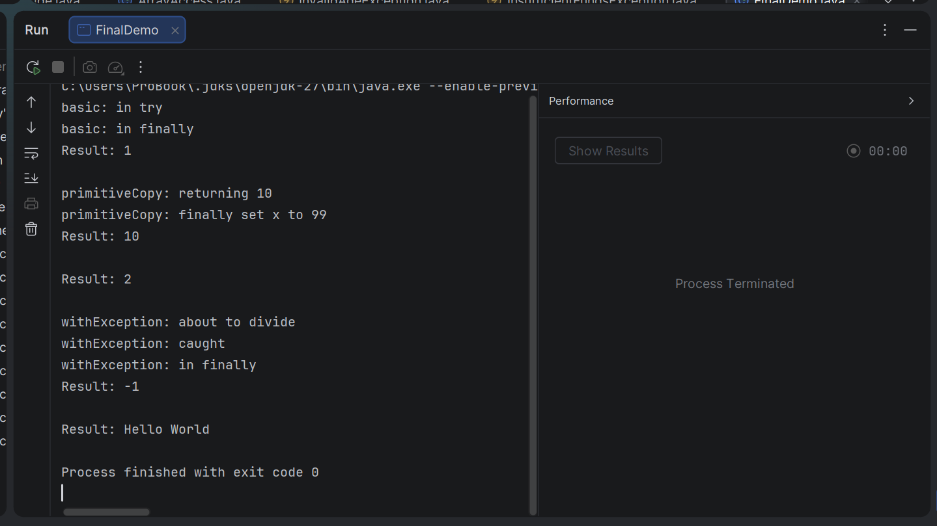

LAB 8
QUESTION 1
import java.util.ArrayList;
import java.util.Collections;
import java.util.List;
public class ArrayListDemo {
public static void main(String[] args) {
List<Integer> numbers = new ArrayList<>();
// Store 10 integers
int[] values = {42, 7, 19, 88, 3, 56, 71, 25, 90, 14};
for (int v : values) {
numbers.add(v); // autoboxing: int -> Integer
}
System.out.println("List: " + numbers);
// Sum
int sum = 0;
for (int n : numbers) {
sum += n; // auto-unboxing: Integer -> int
}
System.out.println("Sum: " + sum);
// Maximum (manual loop)
int max = numbers.get(0);
for (int n : numbers) {
if (n > max) {
max = n;
}
}
System.out.println("Maximum: " + max);
// Reverse order (without changing the original list)
System.out.print("Reversed: [");
for (int i = numbers.size() - 1; i >= 0; i--) {
System.out.print(numbers.get(i));
if (i > 0) {
System.out.print(", ");
}
}
System.out.println("]");
// Shorter alternatives using the Collections class
System.out.println("\n--- Using Collections ---");
System.out.println("Maximum: " + Collections.max(numbers));
List<Integer> copy = new ArrayList<>(numbers);
Collections.reverse(copy); // reverses in place, so we use a copy
System.out.println("Reversed: " + copy);
}
}

OUTPUT
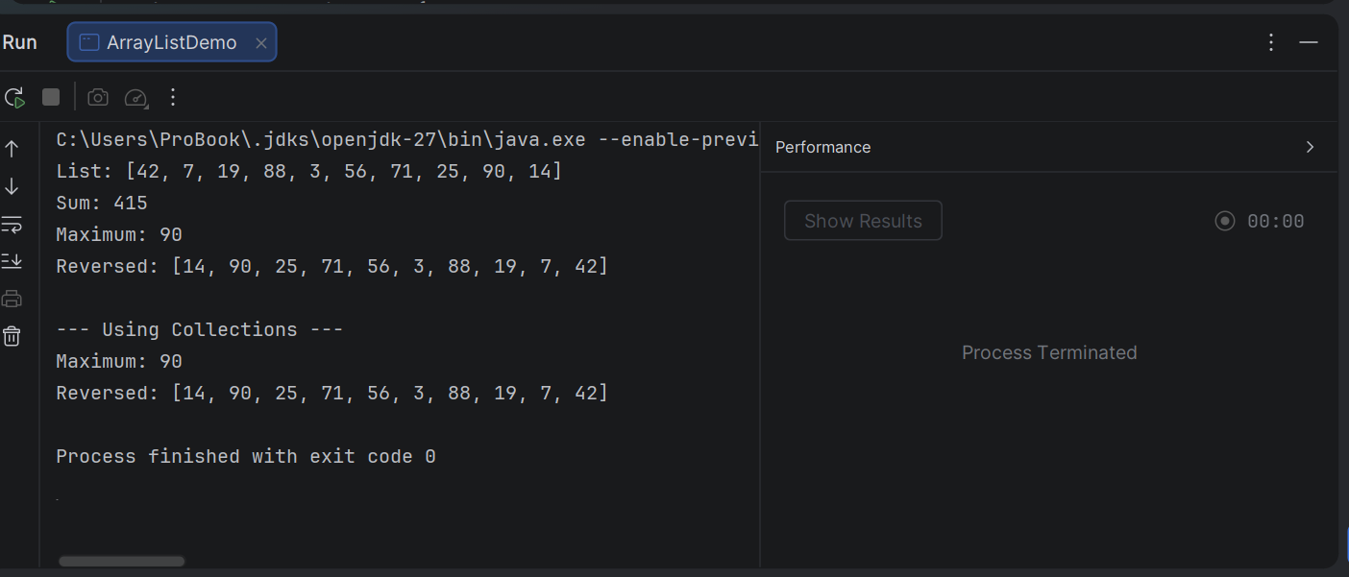

QUESTION 2
import java.util.ArrayList;
import java.util.Arrays;
import java.util.LinkedHashSet;
import java.util.List;
import java.util.Set;
import java.util.TreeSet;
import java.util.HashSet;
public class RemoveDuplicate {
public static void main(String[] args) {
List<String> names = new ArrayList<>(Arrays.asList(
"Tendai", "Alice", "Rudo", "Alice", "Brian",
"Tendai", "Chipo", "Rudo", "Alice"
));
System.out.println("Original list: " + names);
System.out.println("Original size: " + names.size());
// 1. HashSet: removes duplicates, order NOT guaranteed
Set<String> hashSet = new HashSet<>(names);
System.out.println("\nHashSet: " + hashSet);
// 2. LinkedHashSet: removes duplicates, keeps ORIGINAL order
Set<String> linkedSet = new LinkedHashSet<>(names);
System.out.println("LinkedHashSet: " + linkedSet);
// 3. TreeSet: removes duplicates, SORTED alphabetically
Set<String> treeSet = new TreeSet<>(names);
System.out.println("TreeSet: " + treeSet);
// Convert back to a list if a List is needed
List<String> unique = new ArrayList<>(linkedSet);
System.out.println("\nUnique list: " + unique);
System.out.println("Unique size: " + unique.size());
System.out.println("Duplicates removed: " + (names.size() - unique.size()));
}
}

OUTPUT
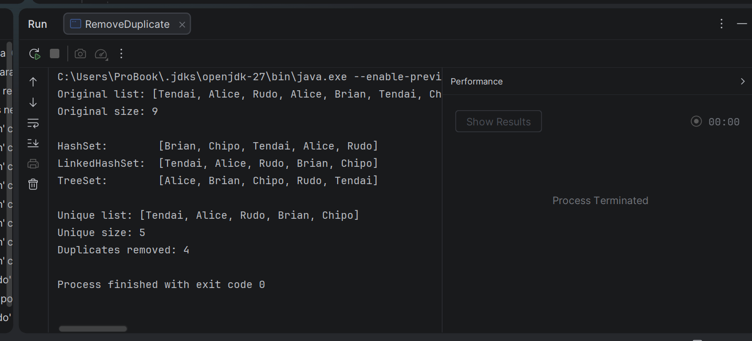

QUESTION 3
// Stack.java
import java.util.ArrayList;
import java.util.EmptyStackException;
import java.util.List;
public class Stack2<T> {
private final List<T> items = new ArrayList<>();
// Add to the top
public void push(T item) {
items.add(item);
}
// Remove and return the top element
public T pop() {
if (isEmpty()) {
throw new EmptyStackException();
}
return items.remove(items.size() - 1);
}
// Return the top element without removing it
public T peek() {
if (isEmpty()) {
throw new EmptyStackException();
}
return items.get(items.size() - 1);
}
public boolean isEmpty() {
return items.isEmpty();
}
public int size() {
return items.size();
}
@Override
public String toString() {
return items.toString(); // bottom ... top
}
}
// StackDemo.java
class StackDemo {
public static void main(String[] args) {
// Stack of Integers
Stack2<Integer> ints = new Stack2<>();
ints.push(10);
ints.push(20);
ints.push(30);
System.out.println("Integer stack: " + ints);
System.out.println("Peek: " + ints.peek());
System.out.println("Pop: " + ints.pop());
System.out.println("Pop: " + ints.pop());
System.out.println("Size: " + ints.size());
System.out.println("Is empty? " + ints.isEmpty());
System.out.println("Pop: " + ints.pop());
System.out.println("Is empty? " + ints.isEmpty());
try {
ints.pop();
} catch (java.util.EmptyStackException e) {
System.out.println("Cannot pop: stack is empty");
}
// The same class works for Strings: reverse a word
Stack2<Character> letters = new Stack2<>();
for (char c : "Hello".toCharArray()) {
letters.push(c);
}
StringBuilder reversed = new StringBuilder();
while (!letters.isEmpty()) {
reversed.append(letters.pop());
}
System.out.println("Reversing \"Hello\": " + reversed);
// ints.push("text"); // COMPILE ERROR: String is not an Integer
}
}

OUTPUT
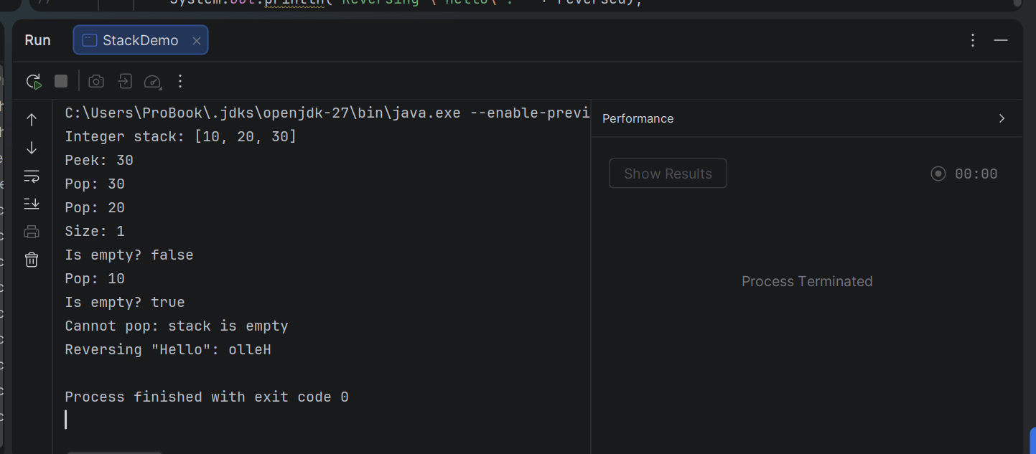

QUESTION 4
import java.util.ArrayList;
import java.util.HashMap;
import java.util.List;
import java.util.Map;
import java.util.Scanner;
public class WordFrequency {
public static void main(String[] args) {
String paragraph = "The cat sat on the mat. The dog sat on the log. "
+ "The cat and the dog are friends.";
// To read from the user instead, uncomment these lines:
// Scanner sc = new Scanner(System.in);
// System.out.println("Enter a paragraph:");
// String paragraph = sc.nextLine();
// 1. Count the words
Map<String, Integer> freq = new HashMap<>();
String[] words = paragraph.toLowerCase().split("[^a-z']+"); // split on anything that isn't a letter
for (String w : words) {
if (w.isEmpty()) {
continue; // skip empty tokens
}
freq.merge(w, 1, Integer::sum); // add 1, or start at 1 if absent
}
// 2. A HashMap has no order, so copy the entries into a list and sort it
List<Map.Entry<String, Integer>> entries = new ArrayList<>(freq.entrySet());
entries.sort((a, b) -> {
int cmp = Integer.compare(b.getValue(), a.getValue()); // highest count first
if (cmp != 0) {
return cmp;
}
return a.getKey().compareTo(b.getKey()); // tie: alphabetical
});
// 3. Print
System.out.println("Word frequencies (highest first):");
for (Map.Entry<String, Integer> e : entries) {
System.out.printf("%-10s %d%n", e.getKey(), e.getValue());
}
System.out.println("\nTotal words: " + words.length);
System.out.println("Unique words: " + freq.size());
}
}

OUTPUT
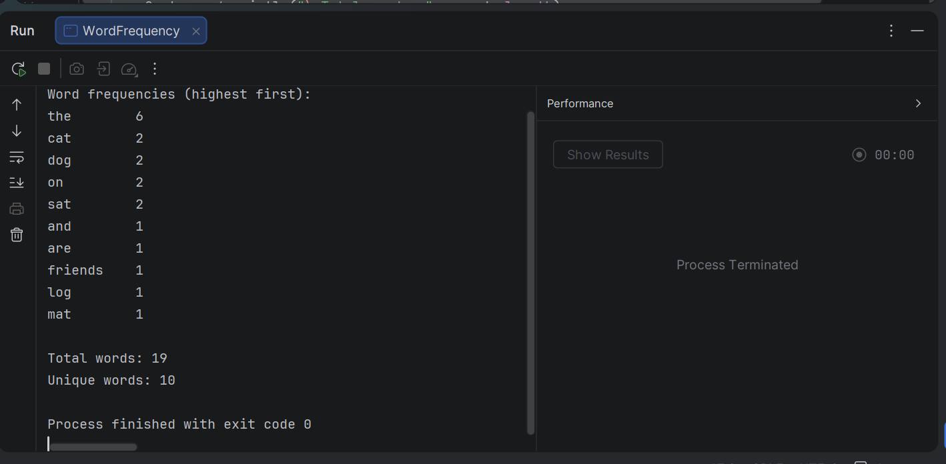

QUESTION 5
import java.util.Arrays;
public class BubbleSortDemo {
public static <T extends Comparable<T>> void bubbleSort(T[] arr) {
int n = arr.length;
for (int pass = 0; pass < n - 1; pass++) {
boolean swapped = false;
for (int i = 0; i < n - 1 - pass; i++) {
if (arr[i].compareTo(arr[i + 1]) > 0) { // arr[i] is bigger, so swap
T temp = arr[i];
arr[i] = arr[i + 1];
arr[i + 1] = temp;
swapped = true;
}
}
if (!swapped) {
break; // already sorted, stop early
}
}
}
public static void main(String[] args) {
// Integer[]
Integer[] numbers = {42, 7, 19, 88, 3, 56};
System.out.println("Before: " + Arrays.toString(numbers));
bubbleSort(numbers);
System.out.println("After: " + Arrays.toString(numbers));
// String[]
String[] names = {"Tendai", "Alice", "Rudo", "Brian", "Chipo"};
System.out.println("\nBefore: " + Arrays.toString(names));
bubbleSort(names);
System.out.println("After: " + Arrays.toString(names));
// Double[] also works, because Double implements Comparable<Double>
Double[] decimals = {3.5, -1.2, 9.9, 0.0};
bubbleSort(decimals);
System.out.println("\nDoubles: " + Arrays.toString(decimals));
// int[] primitives = {5, 2, 8};
// bubbleSort(primitives); // COMPILE ERROR
}
}

OUTPUT
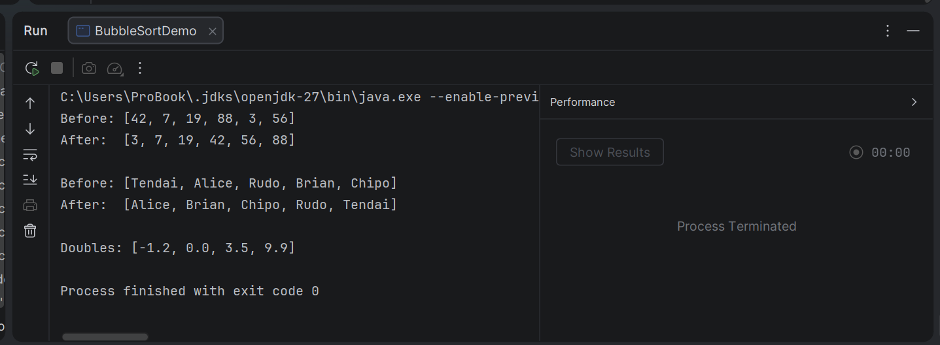

LAB 9
QUESTION 1
// Level.java
public enum Level {
LOW, MEDIUM, HIGH
}
// Level.java
class LevelDemo{
// Classic switch statement
public static void printAdvice(Level level) {
switch (level) {
case LOW:
System.out.println("LOW: All is calm. Carry on as normal.");
break;
case MEDIUM:
System.out.println("MEDIUM: Stay alert and keep an eye on things.");
break;
case HIGH:
System.out.println("HIGH: Take action now!");
break;
}
}
// Modern switch expression (Java 14+): returns a value, no break needed
public static String adviceFor(Level level) {
return switch (level) {
case LOW -> "All is calm. Carry on as normal.";
case MEDIUM -> "Stay alert and keep an eye on things.";
case HIGH -> "Take action now!";
};
}
public static void main(String[] args) {
// Loop over every constant using values()
for (Level l : Level.values()) {
printAdvice(l);
}
System.out.println();
Level current = Level.MEDIUM;
System.out.println("Current level: " + current);
System.out.println("Advice: " + adviceFor(current));
System.out.println("Ordinal: " + current.ordinal());
// Convert a String to an enum constant
Level fromText = Level.valueOf("HIGH");
System.out.println("From text: " + fromText);
System.out.println("Same constant? " + (fromText == Level.HIGH));
}
}

OUTPUT
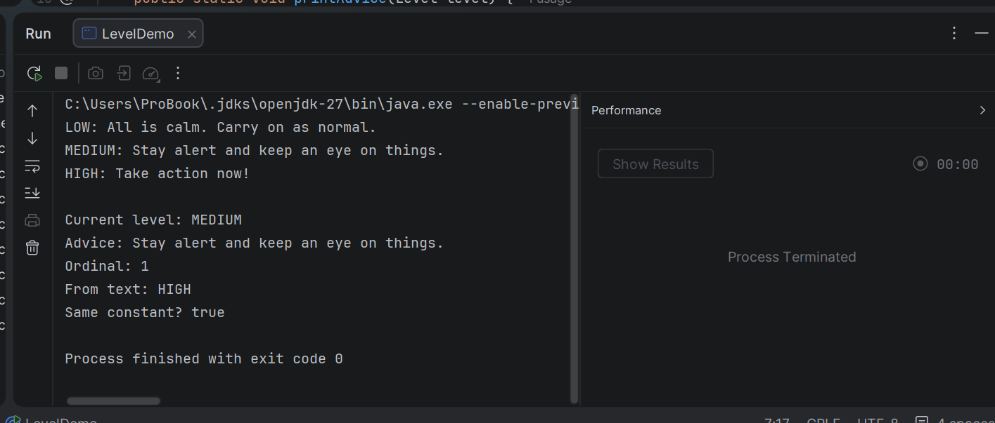

QUESTION 2
import java.util.HashSet;
import java.util.Set;
// Student.java
record Student3(String name, int age) {
}
// RecordDemo.java
class RecordDemo {
public static void main(String[] args) {
Student3 s1 = new Student3("Tendai", 20);
Student3 s2 = new Student3("Tendai", 20);
Student3 s3 = new Student3("Rudo", 22);
// 1. Print: toString() is generated automatically
System.out.println(s1);
System.out.println(s3);
// 2. Compare: equals() compares the component values
System.out.println("s1.equals(s2): " + s1.equals(s2));
System.out.println("s1 == s2: " + (s1 == s2));
System.out.println("s1.equals(s3): " + s1.equals(s3));
System.out.println("Same hashCode: " + (s1.hashCode() == s2.hashCode()));
// 3. Read components: accessor methods have the same name as the component
System.out.println("Name: " + s1.name());
System.out.println("Age: " + s1.age());
// Bonus: equal records work correctly in a HashSet
Set<Student3> set = new HashSet<>();
set.add(s1);
set.add(s2);
set.add(s3);
System.out.println("Set size: " + set.size());
}
}

OUTPUT
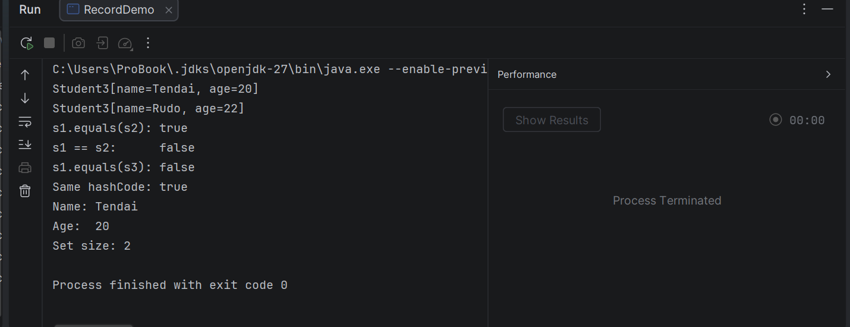

QUESTION 3
// Book.java
import java.util.Objects;
import java.util.HashSet;
import java.util.Set;
public class Book {
private final String isbn;
private final String title;
private final String author;
public Book(String isbn, String title, String author) {
this.isbn = isbn;
this.title = title;
this.author = author;
}
public String getIsbn() { return isbn; }
public String getTitle() { return title; }
public String getAuthor() { return author; }
// Two books are equal if they have the same ISBN
@Override
public boolean equals(Object o) {
if (this == o) return true; // same object
if (o == null || getClass() != o.getClass()) return false;
Book other = (Book) o;
return Objects.equals(isbn, other.isbn); // compare ISBN only
}
// Must use the same field(s) as equals()
@Override
public int hashCode() {
return Objects.hash(isbn);
}
@Override
public String toString() {
return title + " by " + author + " (ISBN " + isbn + ")";
}
}
// BookDemo.java
class BookDemo {
public static void main(String[] args) {
Book b1 = new Book("978-0134685991", "Effective Java", "Joshua Bloch");
Book b2 = new Book("978-0134685991", "Effective Java (3rd Edition)", "J. Bloch"); // same ISBN
Book b3 = new Book("978-0596009205", "Head First Java", "Kathy Sierra");
// equals and hashCode
System.out.println("b1 == b2: " + (b1 == b2));
System.out.println("b1.equals(b2): " + b1.equals(b2));
System.out.println("b1.equals(b3): " + b1.equals(b3));
System.out.println("Same hashCode: " + (b1.hashCode() == b2.hashCode()));
// HashSet rejects duplicates
Set<Book> library = new HashSet<>();
System.out.println("\nAdd b1: " + library.add(b1));
System.out.println("Add b2: " + library.add(b2)); // duplicate ISBN
System.out.println("Add b3: " + library.add(b3));
System.out.println("\nSet size: " + library.size());
System.out.println("Contains new Book with same ISBN? "
+ library.contains(new Book("978-0134685991", "Anything", "Anyone")));
System.out.println("\nBooks in library:");
for (Book b : library) {
System.out.println(" " + b);
}
}
}

OUTPUT
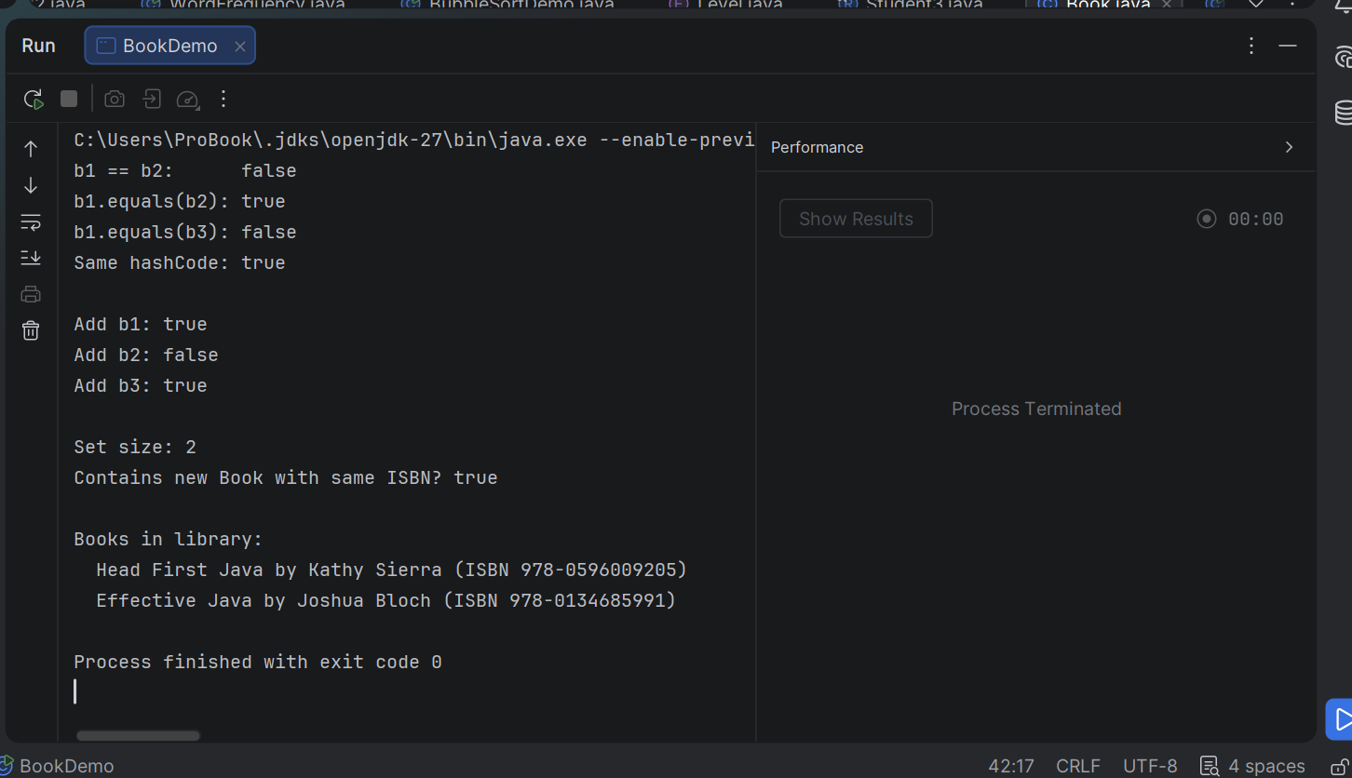

QUESTION 4
// LinkedList.java
import java.util.Iterator;
import java.util.NoSuchElementException;
public class LinkedList<T> implements Iterable<T> {
// Static nested class: a Node doesn't need access to any LinkedList object
private static class Node<T> {
private final T data;
private Node<T> next;
Node(T data) {
this.data = data;
}
}
private Node<T> head;
private Node<T> tail;
private int size;
// Add to the end
public void add(T item) {
Node<T> node = new Node<>(item);
if (head == null) {
head = node;
tail = node;
} else {
tail.next = node;
tail = node;
}
size++;
}
// Add to the front
public void addFirst(T item) {
Node<T> node = new Node<>(item);
node.next = head;
head = node;
if (tail == null) {
tail = node;
}
size++;
}
public T get(int index) {
if (index < 0 || index >= size) {
throw new IndexOutOfBoundsException("Index " + index + ", size " + size);
}
Node<T> current = head;
for (int i = 0; i < index; i++) {
current = current.next;
}
return current.data;
}
public int size() { return size; }
public boolean isEmpty() { return size == 0; }
// Required by Iterable<T>: this is what makes for-each work
@Override
public Iterator<T> iterator() {
return new ListIterator();
}
// Inner (non-static) class: needs access to this list's head
private class ListIterator implements Iterator<T> {
private Node<T> current = head; // each iterator has its own position
@Override
public boolean hasNext() {
return current != null;
}
@Override
public T next() {
if (!hasNext()) {
throw new NoSuchElementException();
}
T value = current.data;
current = current.next;
return value;
}
}
@Override
public String toString() {
StringBuilder sb = new StringBuilder("[");
for (T item : this) { // uses our own iterator
if (sb.length() > 1) sb.append(", ");
sb.append(item);
}
return sb.append("]").toString();
}
}
// ListDemo.java
class ListDemo {
public static void main(String[] args) {
LinkedList<String> names = new LinkedList<>();
names.add("Mellisa");
names.add("Merit");
names.add("Tapiwa");
names.addFirst("Faith");
System.out.println("List: " + names);
System.out.println("Size: " + names.size());
System.out.println("get(2): " + names.get(2));
System.out.println("\nFor-each loop:");
for (String n : names) {
System.out.println(" " + n);
}
LinkedList<Integer> nums = new LinkedList<>();
nums.add(10);
nums.add(20);
nums.add(30);
int sum = 0;
for (int n : nums) {
sum += n;
}
System.out.println("\nSum of numbers: " + sum);
// Each for-each creates its own iterator, so nested loops work
LinkedList<Integer> pair = new LinkedList<>();
pair.add(1);
pair.add(2);
System.out.println("\nNested loops:");
for (int a : pair) {
for (int b : pair) {
System.out.println(" " + a + "-" + b);
}
}
}
}

OUTPUT
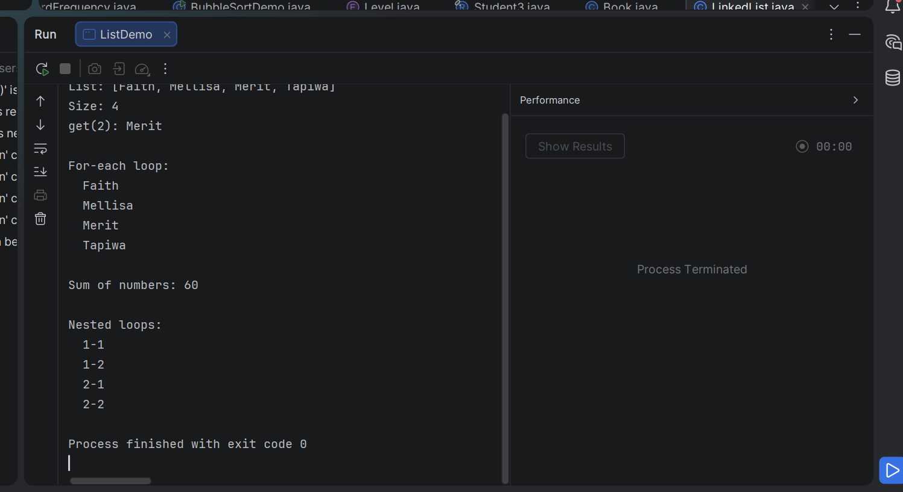

QUESTION 5
import java.util.EnumMap;
import java.util.Map;
// Each constant carries its value in cents, set through a private constructor.
enum Coin {
PENNY(1), NICKEL(5), DIME(10), QUARTER(25);
private final int value;
Coin(int value) { this.value = value; }
int value() { return value; }
// Fewest coins for 'amount' cents. Greedy works because US denominations
// are a canonical coin system. values() is in ascending order, so walk it backwards.
static Map<Coin, Integer> fewestCoins(int amount) {
if (amount < 0) throw new IllegalArgumentException("Negative amount");
Map<Coin, Integer> result = new EnumMap<>(Coin.class);
Coin[] coins = values();
for (int i = coins.length - 1; i >= 0; i--) {
int count = amount / coins[i].value;
if (count > 0) {
result.put(coins[i], count);
amount %= coins[i].value;
}
}
return result;
}
static int totalCoins(Map<Coin, Integer> change) {
return change.values().stream().mapToInt(Integer::intValue).sum();
}
}
class CoinDemo {
public static void main(String[] args) {
int[] amounts = {0, 1, 30, 41, 99, 100, 168};
for (int amount : amounts) {
Map<Coin, Integer> change = Coin.fewestCoins(amount);
System.out.println(amount + " cents -> " + change
+ " (" + Coin.totalCoins(change) + " coins)");
}
}
}

OUTPUT
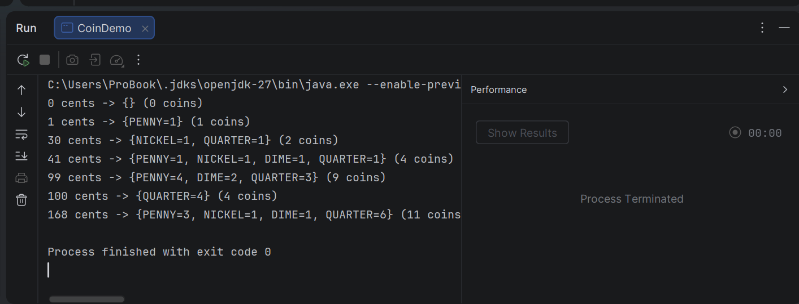

LAB 10
QUESTION 1

import java.io.BufferedReader;
import java.io.BufferedWriter;
import java.io.IOException;
import java.nio.file.Files;
import java.nio.file.Path;
import java.nio.file.Paths;
import java.util.Scanner;
public class SaveLines {
public static void main(String[] args) {
Path file = Paths.get("lines.txt");
Scanner in = new Scanner(System.in);
// WRITE: try-with-resources closes the writer automatically
try (BufferedWriter writer = Files.newBufferedWriter(file)) {
for (int i = 1; i <= 5; i++) {
System.out.print("Enter line " + i + ": ");
writer.write(in.nextLine());
writer.newLine();
}
} catch (IOException e) {
System.err.println("Could not write file: " + e.getMessage());
return;
}
System.out.println("\nSaved to " + file.toAbsolutePath());
// READ BACK
System.out.println("Reading back:");
try (BufferedReader reader = Files.newBufferedReader(file)) {
String line;
int n = 1;
while ((line = reader.readLine()) != null) {
System.out.println(n++ + ": " + line);
}
} catch (IOException e) {
System.err.println("Could not read file: " + e.getMessage());
}
}
}

OUTPUT
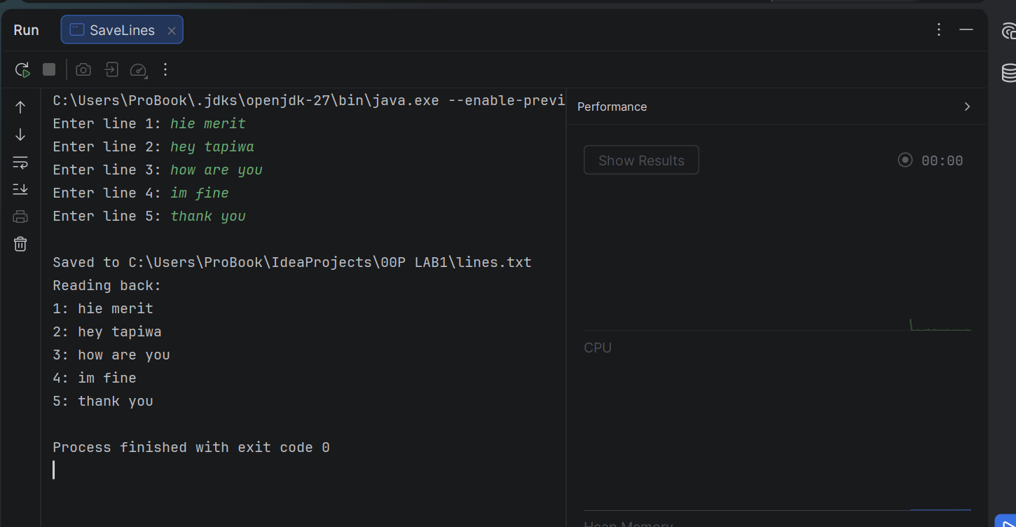

QUESTION 2
import java.util.ArrayList;
import java.util.List;
import java.util.function.Predicate;
public class RemoveEvens {
public static void main(String[] args) {
// List.of is immutable, so copy into an ArrayList
List<Integer> numbers = new ArrayList<>(List.of(1, 2, 3, 4, 5, 6, 7, 8, 9, 10));
System.out.println("Before: " + numbers);
Predicate<Integer> isEven = n -> n % 2 == 0;
numbers.removeIf(isEven); // removes every element for which the predicate is true
System.out.println("After: " + numbers);
}
}

OUTPUT

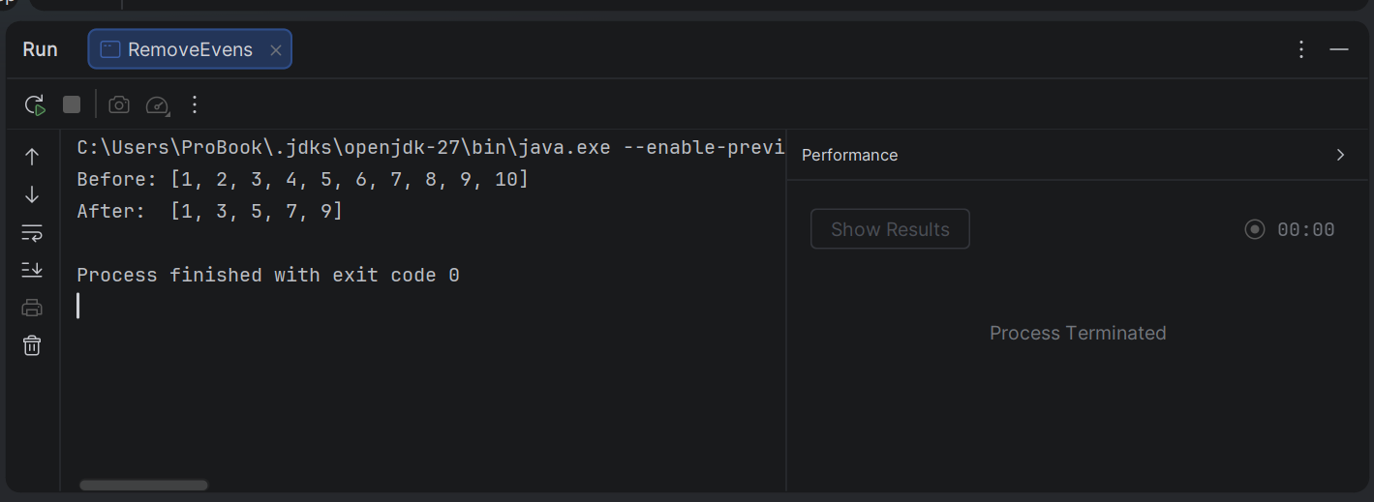

QUESTION 3
import java.io.IOException;
import java.nio.file.Files;
import java.nio.file.Path;
import java.util.ArrayList;
import java.util.List;
import java.util.Scanner;
class FileStats {
public static void main(String[] args) {
Scanner sc = new Scanner(System.in);
List<String> lines = new ArrayList<>();
// Read five lines typed by the user
for (int i = 1; i <= 5; i++) {
System.out.print("Line " + i + ": ");
lines.add(sc.nextLine());
}
Path file = Path.of("notes.txt"); // relative path: created in the working directory
try {
Files.write(file, lines); // save all five lines to the file
List<String> saved = Files.readAllLines(file); // read them back
System.out.println("--- Read back from " + file + " ---");
for (String s : saved) {
System.out.println(s);
}
} catch (IOException e) {
// I/O can fail for reasons outside the program, so report the message
System.out.println("File error: " + e.getMessage());
}
sc.close();
}
}

OUTPUT
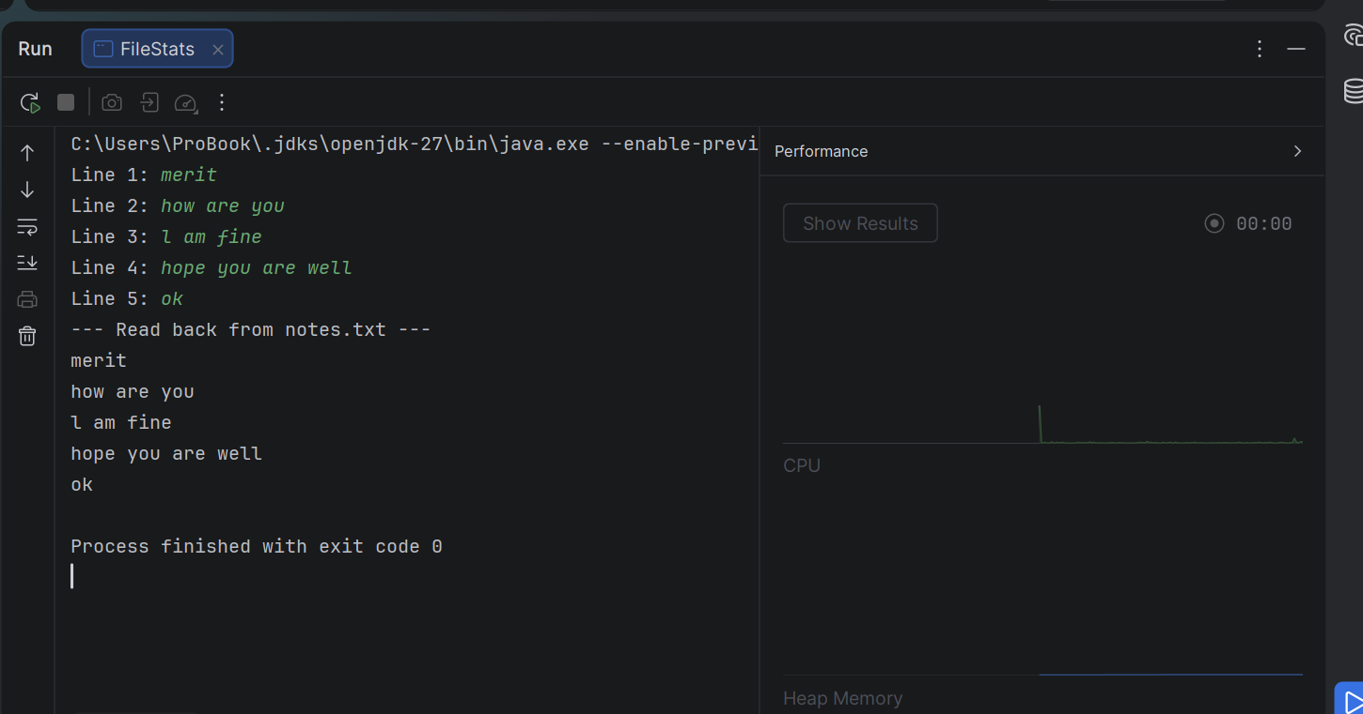

QUESTION 4
import java.util.List;
record Student2(String name, int mark) { }
public class AboveAverage {
public static void main(String[] args) {
List<Student2> students = List.of(
new Student2("Mellisa", 82),
new Student2("Viola", 55),
new Student2("Tapiwa", 91),
new Student2("Lesley", 67),
new Student2("Blessing", 74),
new Student2("Goddy", 48));
// Step 1: class average (orElse handles an empty list)
double average = students.stream()
.mapToInt(Student2::mark)
.average()
.orElse(0);
System.out.printf("Class average: %.2f%n", average);
// Step 2: filter above average, extract names, sort alphabetically
System.out.println("Above average:");
students.stream()
.filter(s -> s.mark() > average)
.map(Student2::name)
.sorted()
.forEach(System.out::println);
}
}

OUTPUT

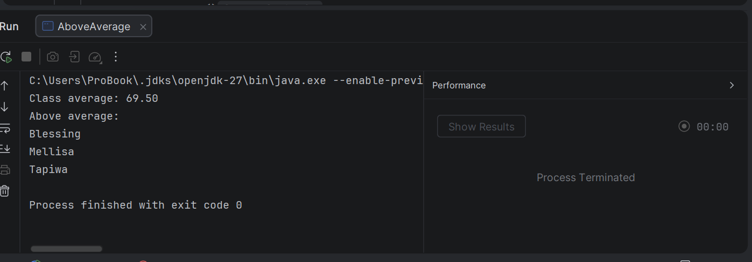
QUESTION 5
import java.io.IOException;
import java.nio.file.Files;
import java.nio.file.Path;
import java.util.ArrayList;
import java.util.List;
import java.util.Map;
import java.util.TreeMap;
import java.util.stream.Collectors;
record Learner(String name, int roll, double gpa) {
static Learner fromCsv(String line) {
String[] p = line.split(",");
return new Learner(p[0].trim(), Integer.parseInt(p[1].trim()), Double.parseDouble(p[2].trim()));
}
}
public class GradeReports {
// Grade band from GPA (4.0 scale): A >= 3.5, B >= 3.0, otherwise C
static String band(Learner l) {
if (l.gpa() >= 3.5) return "A";
if (l.gpa() >= 3.0) return "B";
return "C";
}
public static void main(String[] args) throws IOException {
Path csv = Path.of("learners.csv");
// Create sample data on first run so the program always has something to load
if (!Files.exists(csv)) {
Files.write(csv, List.of(
"Tariro,101,3.8", "Farai,102,3.1", "Rudo,103,3.9",
"Kuda,104,2.4", "Ada,105,3.5", "Tendai,106,2.9", "Nomsa,107,3.0"));
System.out.println("learners.csv not found - created a sample file.");
}
// LOAD
List<Learner> learners = new ArrayList<>();
for (String line : Files.readAllLines(csv)) {
if (!line.isBlank()) learners.add(Learner.fromCsv(line));
}
System.out.println(learners.size() + " learners loaded");
// GROUP: Map<band, List<Learner>>; TreeMap keeps the bands in order A, B, C
Map<String, List<Learner>> byBand = learners.stream()
.collect(Collectors.groupingBy(GradeReports::band, TreeMap::new, Collectors.toList()));
// WRITE one report file per band
for (Map.Entry<String, List<Learner>> entry : byBand.entrySet()) {
String band = entry.getKey();
List<String> report = new ArrayList<>();
report.add("Band " + band + " report (" + entry.getValue().size() + " learners)");
report.add("----------------------------------");
entry.getValue().stream()
.sorted((a, b) -> Double.compare(b.gpa(), a.gpa())) // highest GPA first
.forEach(l -> report.add(String.format("%-10s roll=%d gpa=%.1f", l.name(), l.roll(), l.gpa())));
Path out = Path.of("report_" + band + ".txt");
Files.write(out, report);
System.out.println("Wrote " + out + " (" + entry.getValue().size() + " learners)");
}
}
}

OUTPUT
